* An Exploration of electricity consumption patterns

Introduction

Electricity consumption patterns are an important topic that affect both individuals and society as a whole. Understanding how electricity is used and where it is being wasted can help us make informed decisions about energy conservation and sustainability.

1.1-overview

The rise of smart technologies and the Internet of Things (IoT), there are now more opportunities than ever to collect and analyze data on energy consumption patterns.

1.2-purpose

The purpose of exploring electricity consumption patterns is to gain a better understanding of how energy is being used and wasted in our homes, businesses, and communities. By identifying these patterns, we can make informed decisions about how to conserve energy and reduce our carbon footprint. Additionally, this information can be used to develop more efficient technologies and infrastructure to support a sustainable future. Ultimately, the goal is to promote responsible energy use and ensure that we have access to affordable and reliable electricity for years to come.

2.Problem Definition & Design Thinking

The problem definition for exploring electricity consumption patterns is that the way we currently consume electricity is not sustainable in the long term. The increasing demand for electricity has led to the depletion of natural resources, pollution, and other environmental issues. Additionally, the cost of electricity is increasing, making it difficult for some individuals and communities to access this essential resource.

2.1 Empathy map

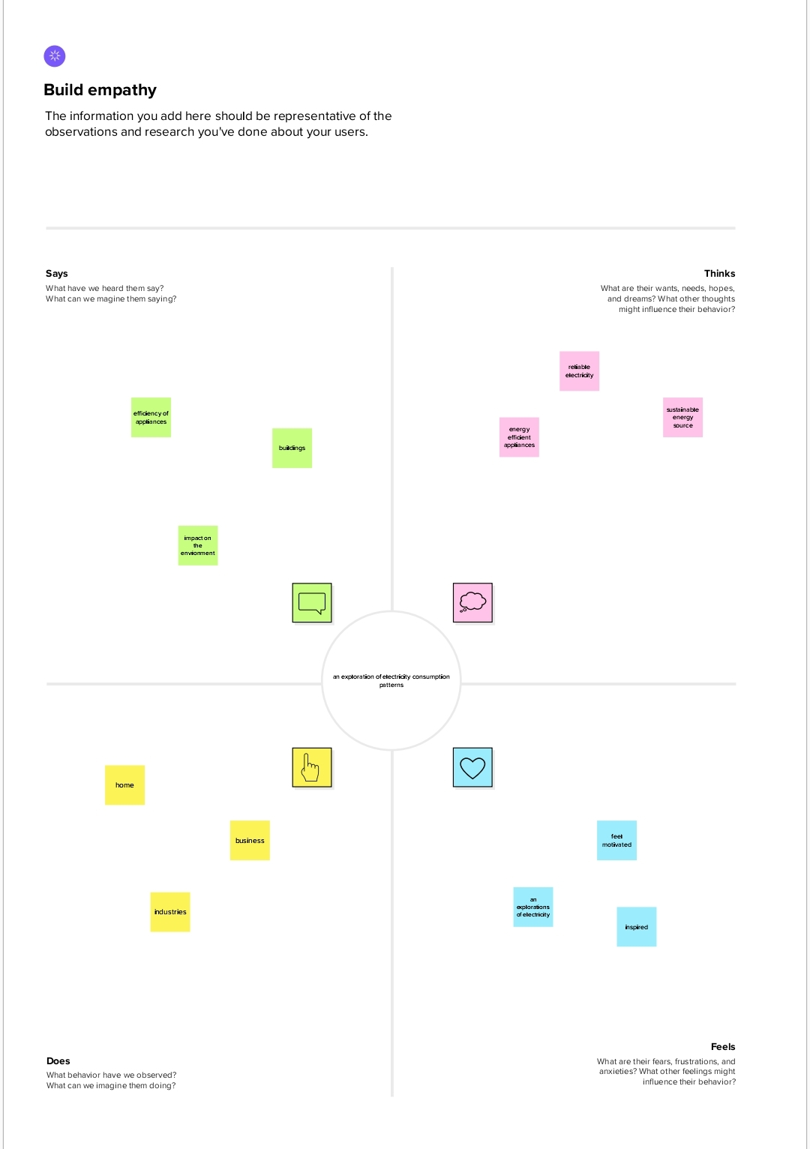

2.2-Ideation & Brain Storming Map

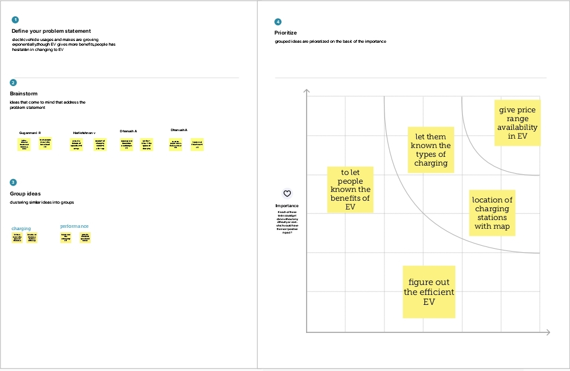3. Result

3.1-Data collection & Extraction from database

For the project the data was collected from Kaggle(www.kaggle.com).Data collection is the process of gathering and measuring information on variables of interest, in an established systematic fashion that enables one to answer stated research questions, test hypotheses, and evaluate outcomes and generate insights from the data.

The dataset contains

1.Get familiar with the data

2.Explore summary statistics

3.Visualize the data

4.Look for correlations

5.Apply machine learning techniques

3.2 Data Visualization

Data visualization is the process of creating graphical representations of data in order to help people understand and explore the information. The goal of data visualization is to make complex data sets more accessible, intuitive, and easier to interpret. By using visual elements such as charts, graphs, and maps, data visualizations.

3.2.1-Quaterwise usage

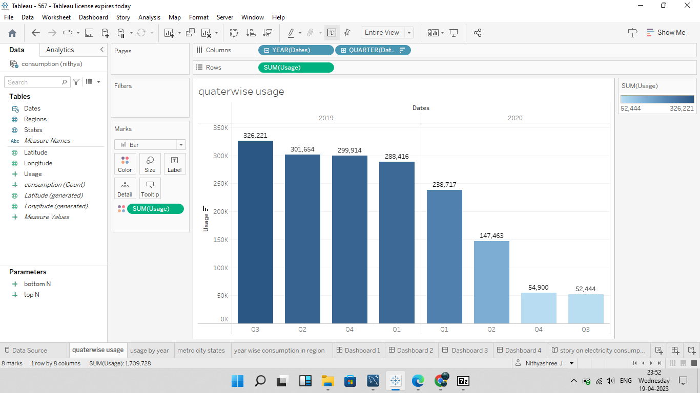

3.2.2-usage by year

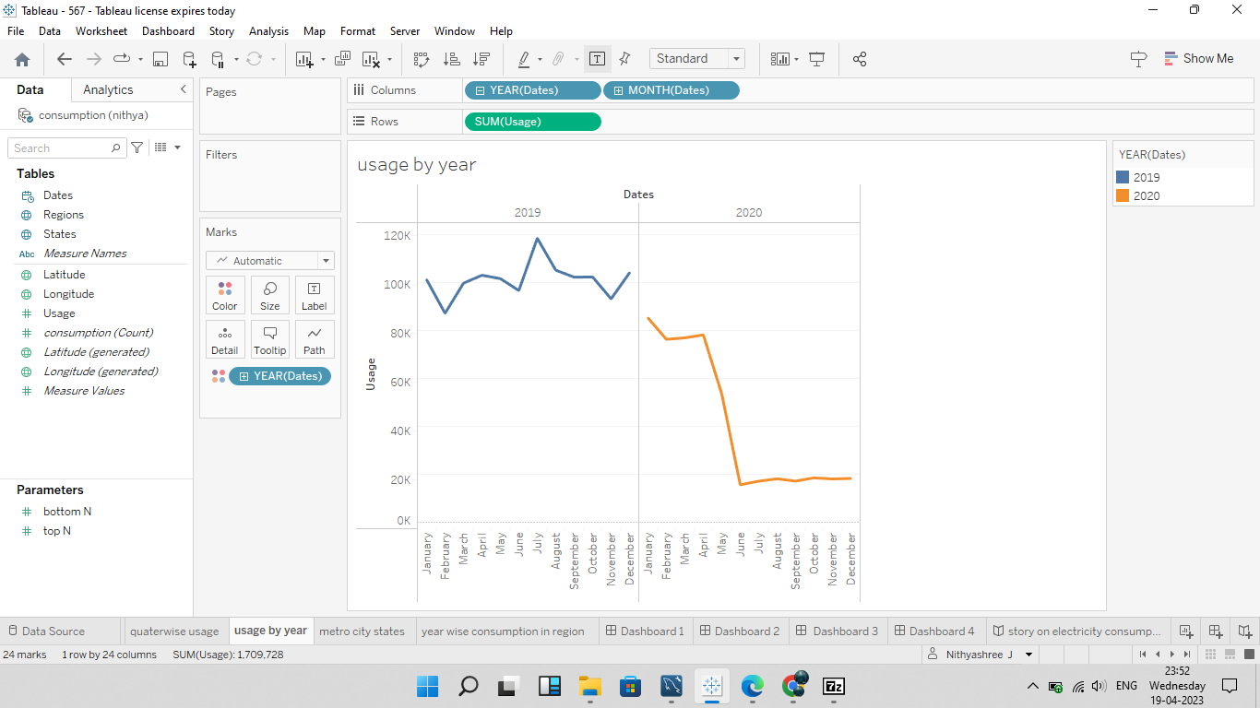

3.2.3-Metro city states

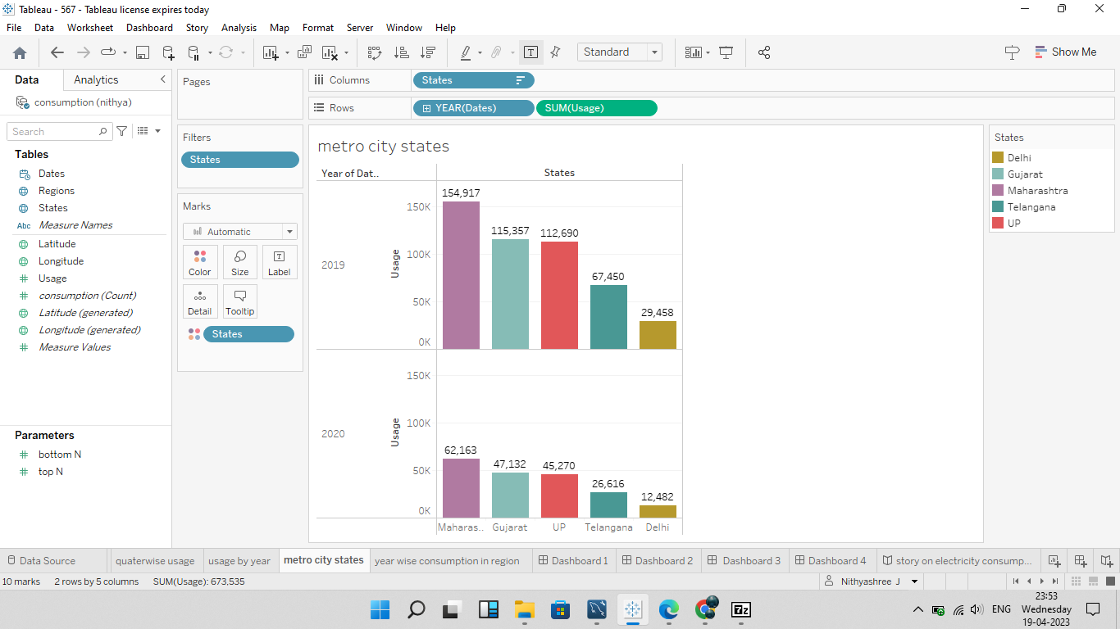

3.2.4-Year wise consumption in region

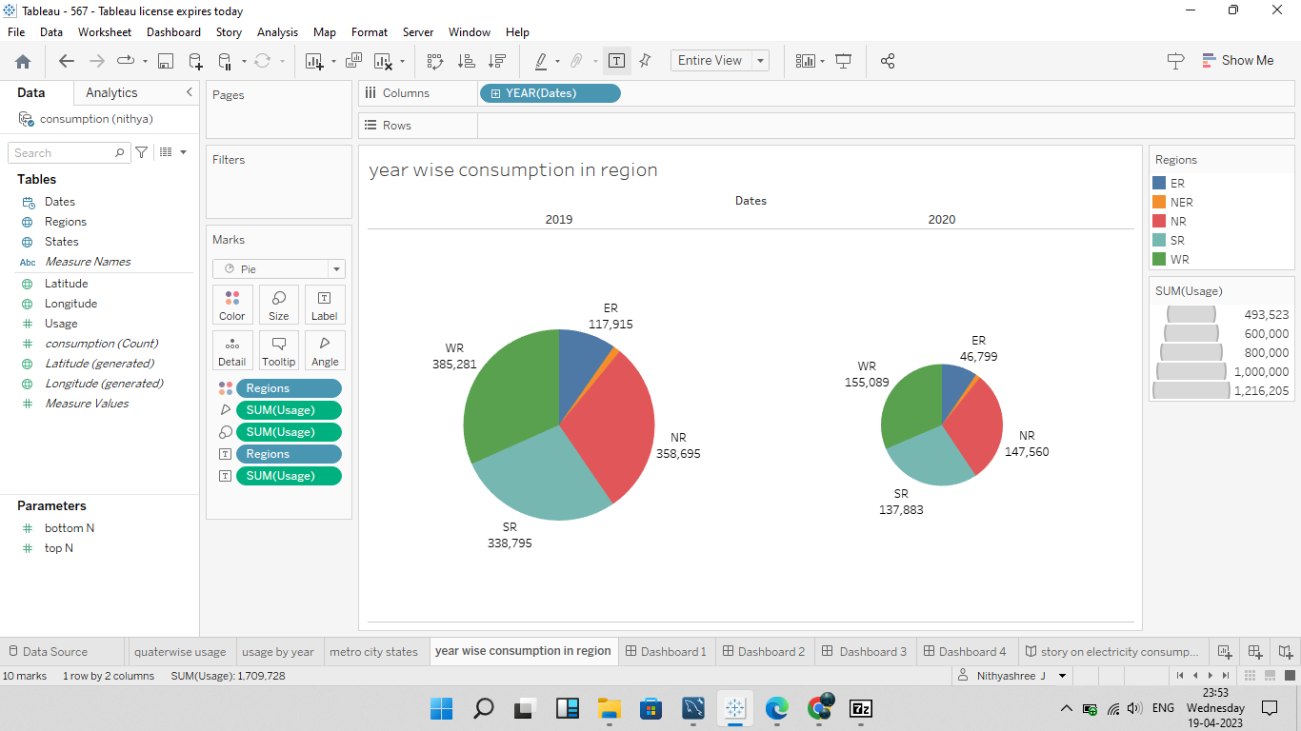

3.2.5-Story on electricity consumption in india

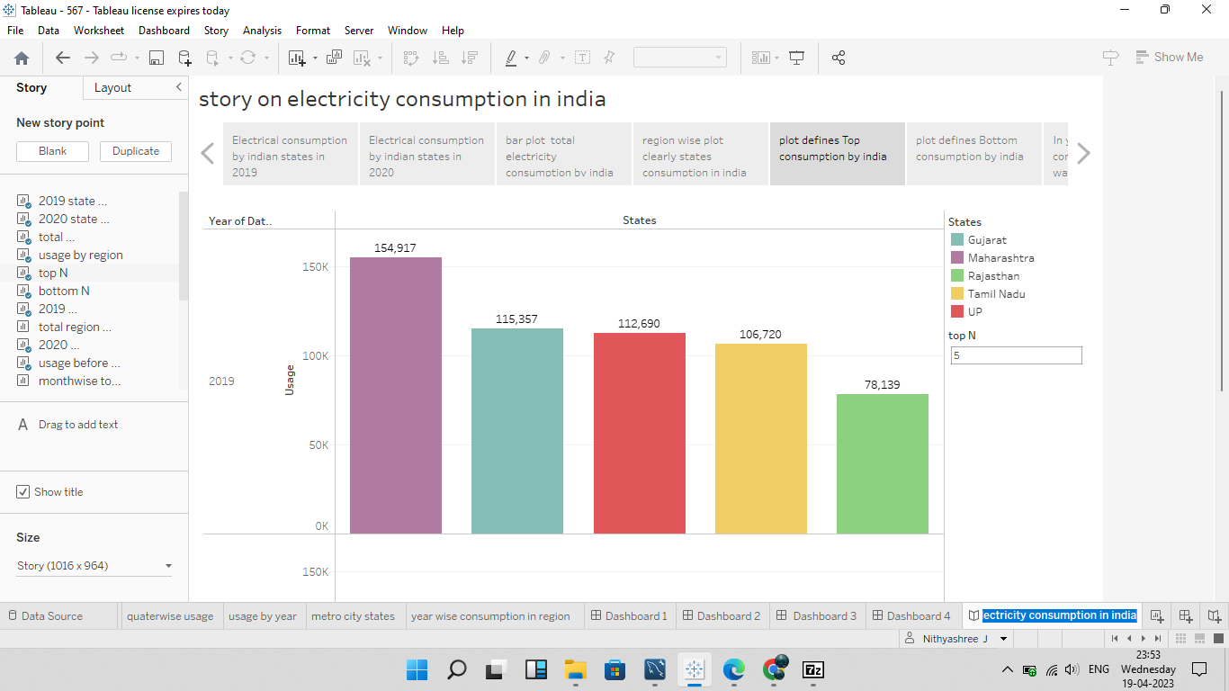

3.2.6-2019 state consumption

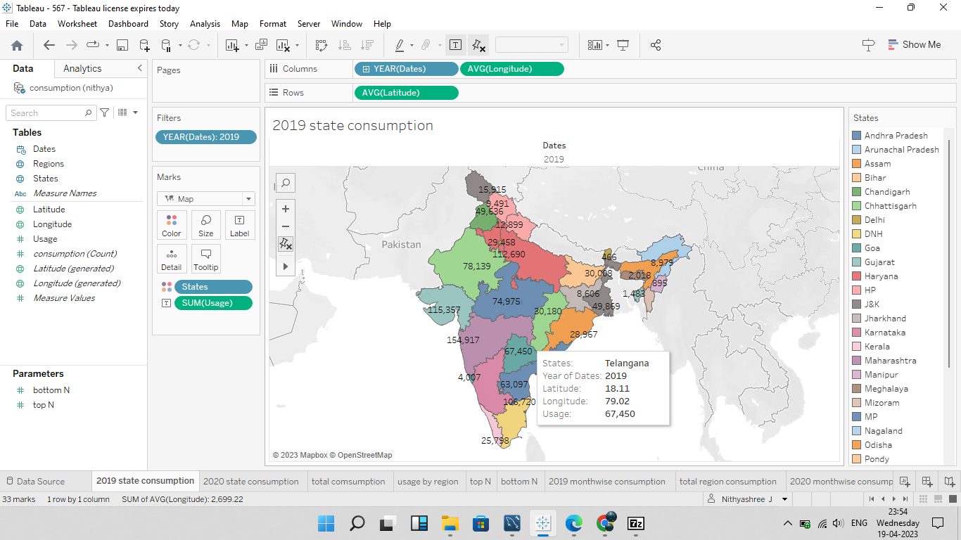

3.2.7- Total consumption

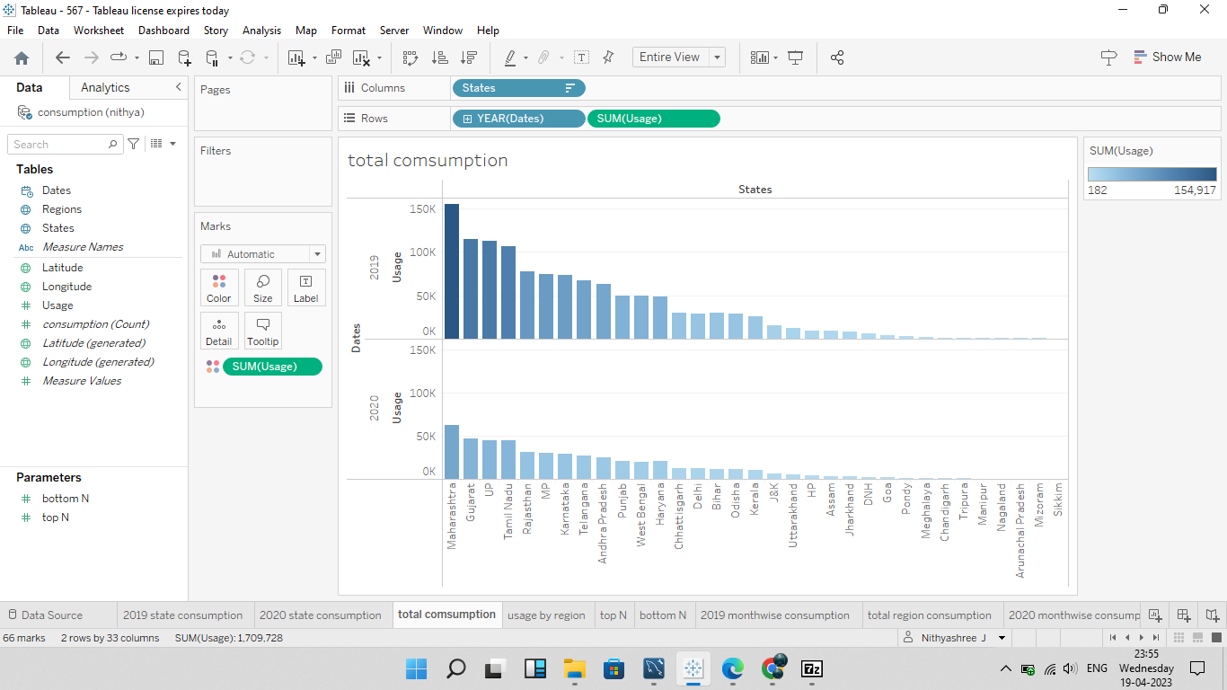

3.2.8-Usage by region

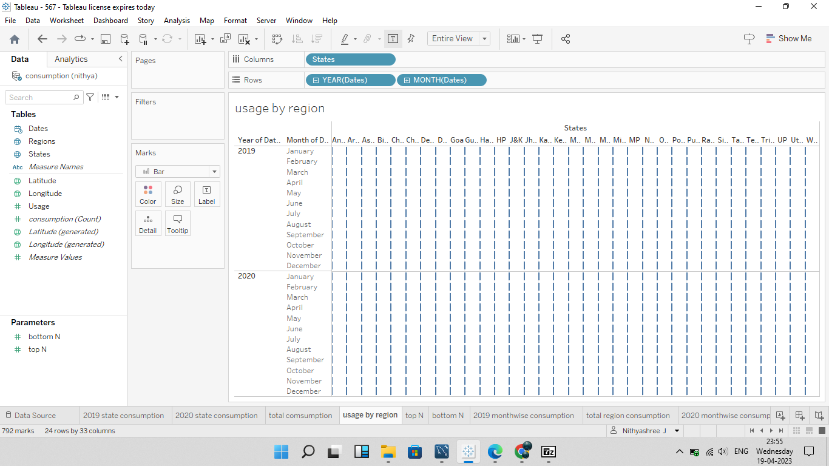

3.2.9-Top N

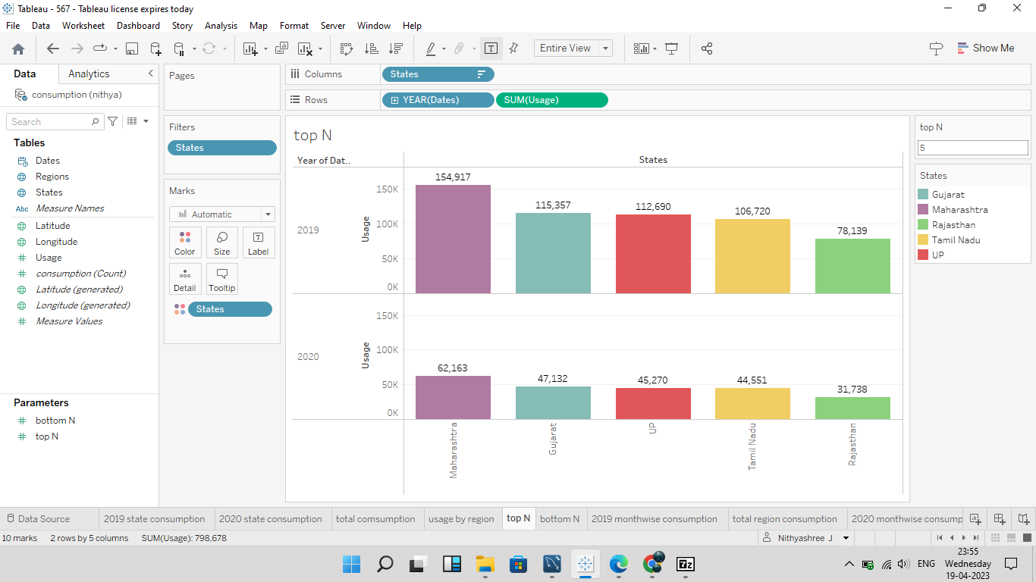

3.2.10-Bottom N

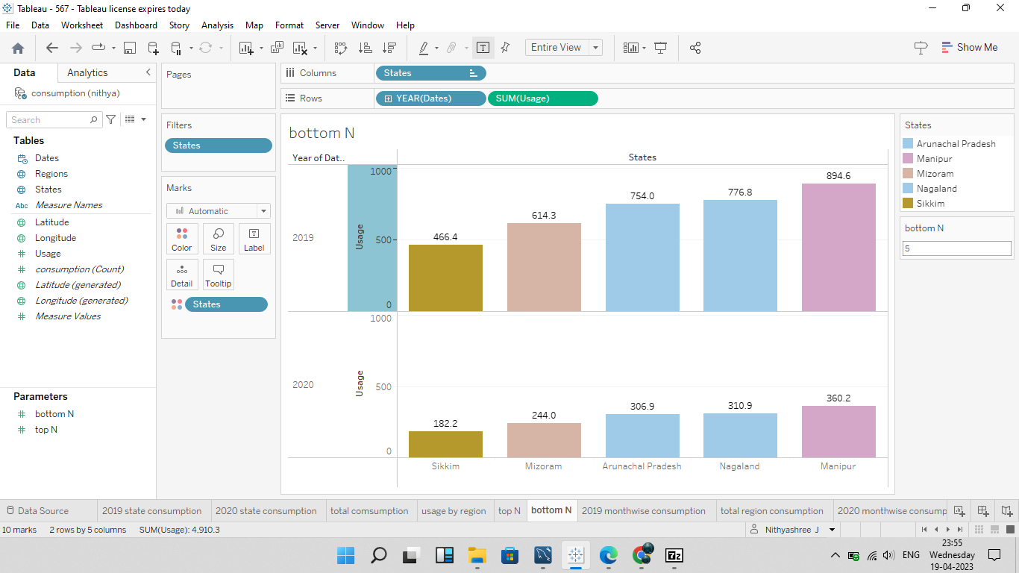

3.2.11-2019 month wise consumption

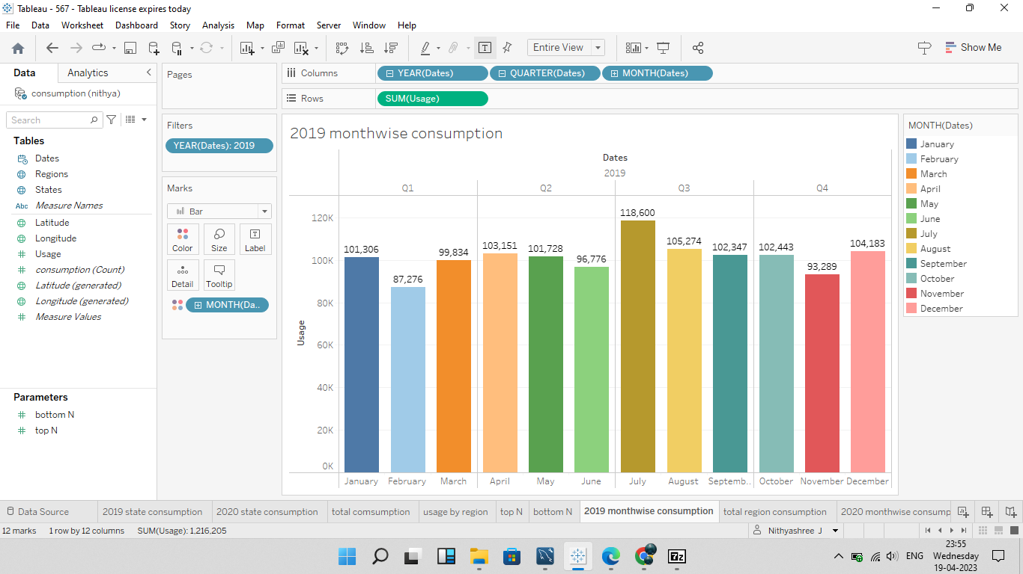

3.2.12-Total region consumption

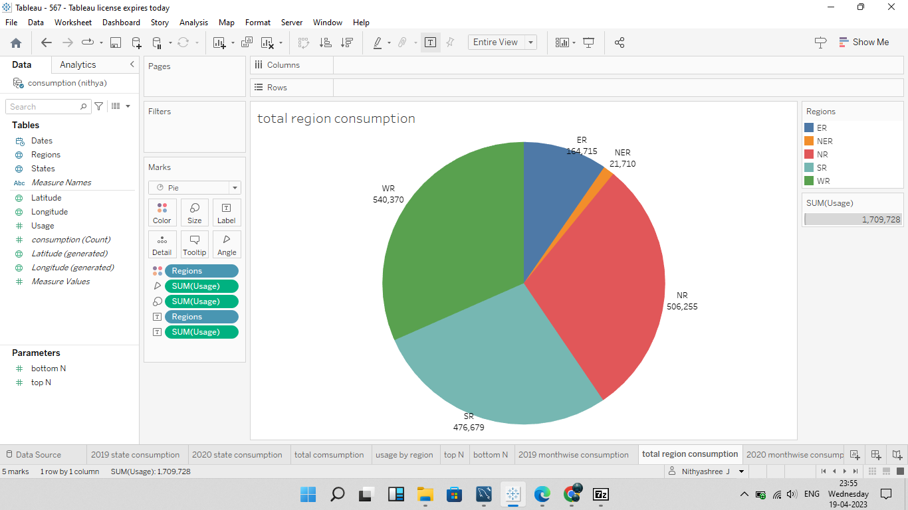

3.2.13-2020 month wise consumption

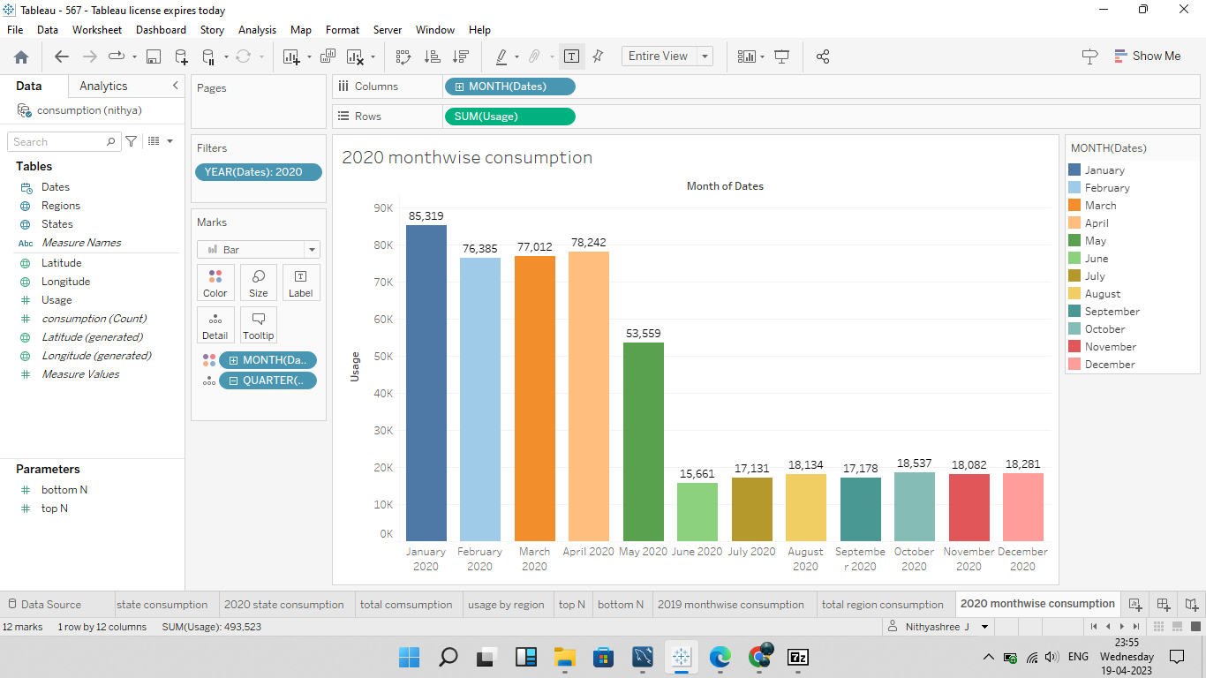

3.3 Dashboard

A dashboard is a graphical user interface (GUI) that displays information and data in an organized, easy-to-read format. Dashboards are often used to provide real-time monitoring and analysis of data, and are typically designed for a specific purpose or use case.

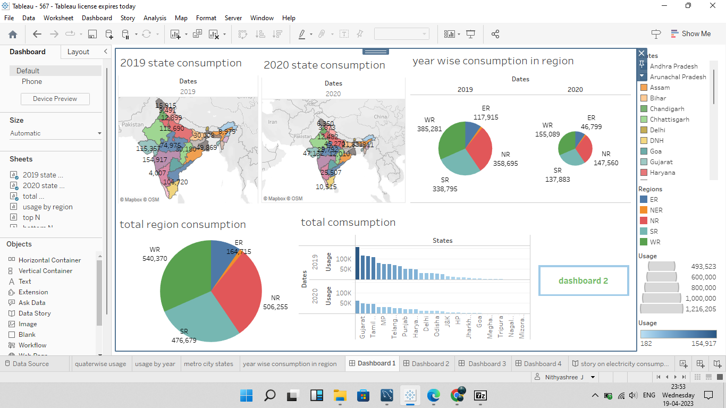

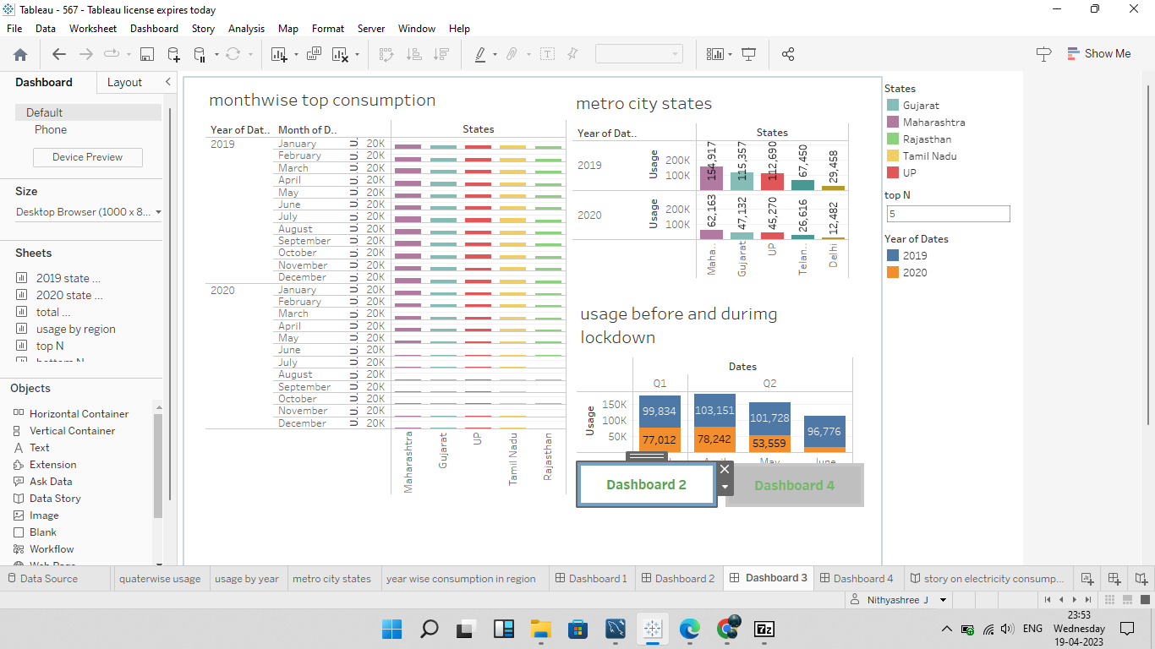

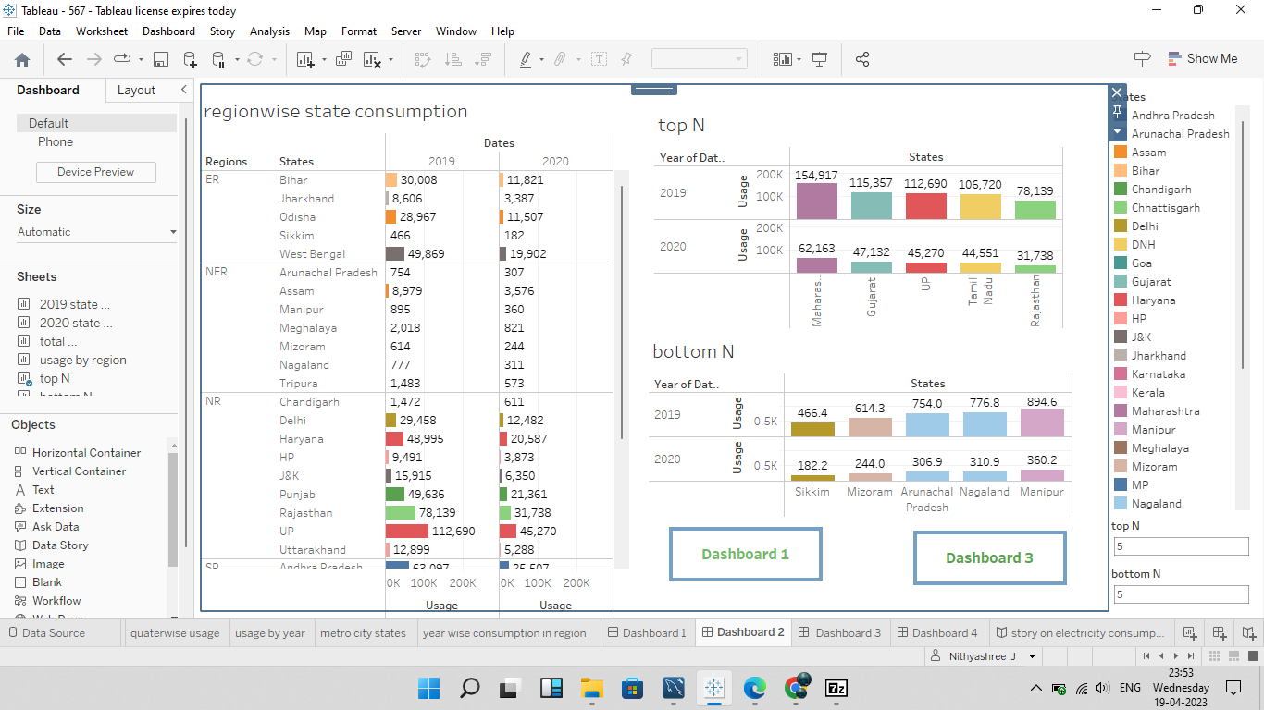

3.4 Story



4. ADVANTAGES & DISADVANTAGES

ADVANTAGE:

1.Electricity is a clean source of energy and does not produce harmful pollutants or emissions like other forms of energy such as fossil fuels.

2.Electricity can be generated from renewable sources such as solar, wind, hydro, and geothermal power. This makes it a sustainable and environmentally friendly option.

3.Electricity can be used for a wide range of applications including transportation, heating, cooling, lighting, and powering electronic devices.

4.Electricity is easily transported over long distances with minimal loss of energy through transmission lines and grids.

5.The availability of electricity has transformed the way people live and work, providing convenience and increasing productivity.

Disadvantages:

1.The production of electricity can be expensive and requires significant investment in infrastructure and technology.

2.Electricity is dependent on the availability of natural resources and weather conditions for renewable sources of energy such as solar and wind power.

3.The use of electricity can contribute to climate change if it is generated from non-renewable sources such as coal and natural gas.

4.The production and disposal of batteries used to store electricity can have negative environmental impacts.

5.Electrical power systems can be vulnerable to blackouts and disruptions during extreme weather events or other natural disasters.

5.APPLICATION

1.Smart home devices: Smart home devices like smart thermostats, smart plugs, and smart light bulbs can monitor and control your electricity usage in real-time.

2.Energy monitoring apps: These apps connect to your smart meter or other monitoring devices to provide detailed information about your energy consumption patterns. Some examples include EnergyHub, Neurio, and Sense.

3.Utility company apps: Many utility companies have their own apps that allow you to track your usage, view your bill, and find ways to save on energy.

4.Home energy audits: Some companies offer professional energy audits to help you identify areas where you can reduce your energy consumption.

By using these applications, you can gain insight into your energy consumption patterns, identify areas where you can save on energy, and ultimately reduce your carbon footprint.

6.CONCLUSION

Exploring electricity consumption patterns applications is a great way to become more aware of how we are using energy and identify areas where we can make changes to reduce our energy consumption. By tracking our energy usage in real-time, we can adjust our habits and make smarter choices that lead to a more sustainable future. Whether it's through smart home devices, energy monitoring apps, or professional energy audits, there are many tools available that can help us become more energy-efficient and reduce our carbon footprint.

7.FUTURE SCOPE:

Electricity consumption is an important topic that has been gaining attention for many years. The future of electricity consumption is likely to involve a significant increase in renewable energy sources, such as wind, solar, and hydroelectric power. These sources of energy are becoming more efficient and affordable, making them a popular choice for many consumers. One of the biggest future scopes for electricity consumption is the growth of electric vehicles. As electric cars become more affordable and accessible, the demand for electricity will rise. This could lead to an increase in the use of renewable energy sources, as well as the development of new technologies to store and transport electricity. Another area of growth is in smart homes and buildings. With the use of smart technology, homeowners and businesses can monitor and manage their energy usage more efficiently. This can lead to significant cost savings and a reduction in carbon emissions. Finally, the growth of the Internet of Things (IoT) is likely to have a significant impact on electricity consumption. As more devices are connected to the internet, there will be an increase in the demand for electricity to power these devices.

7.web Integration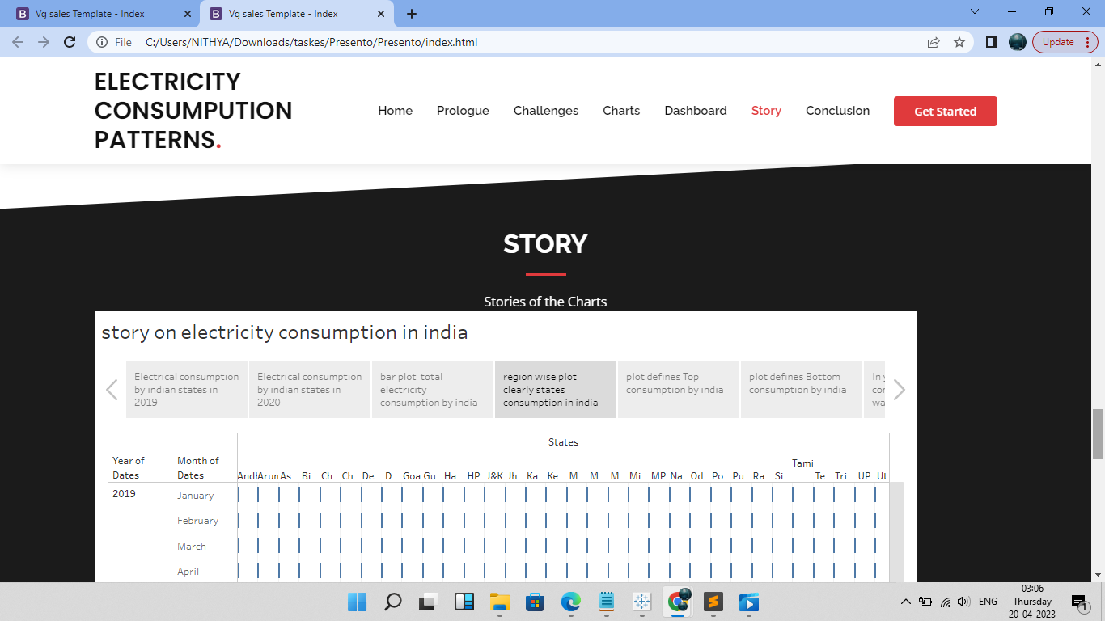

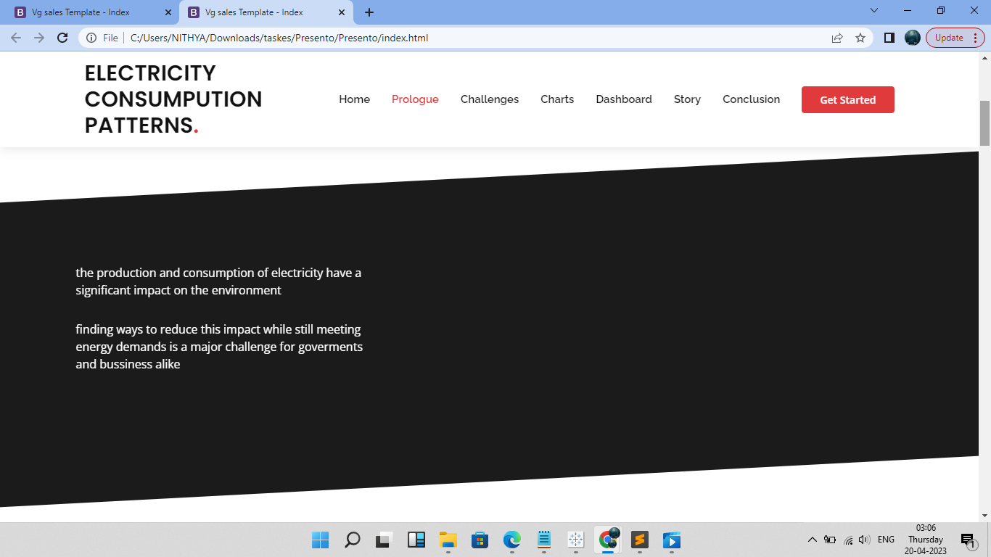

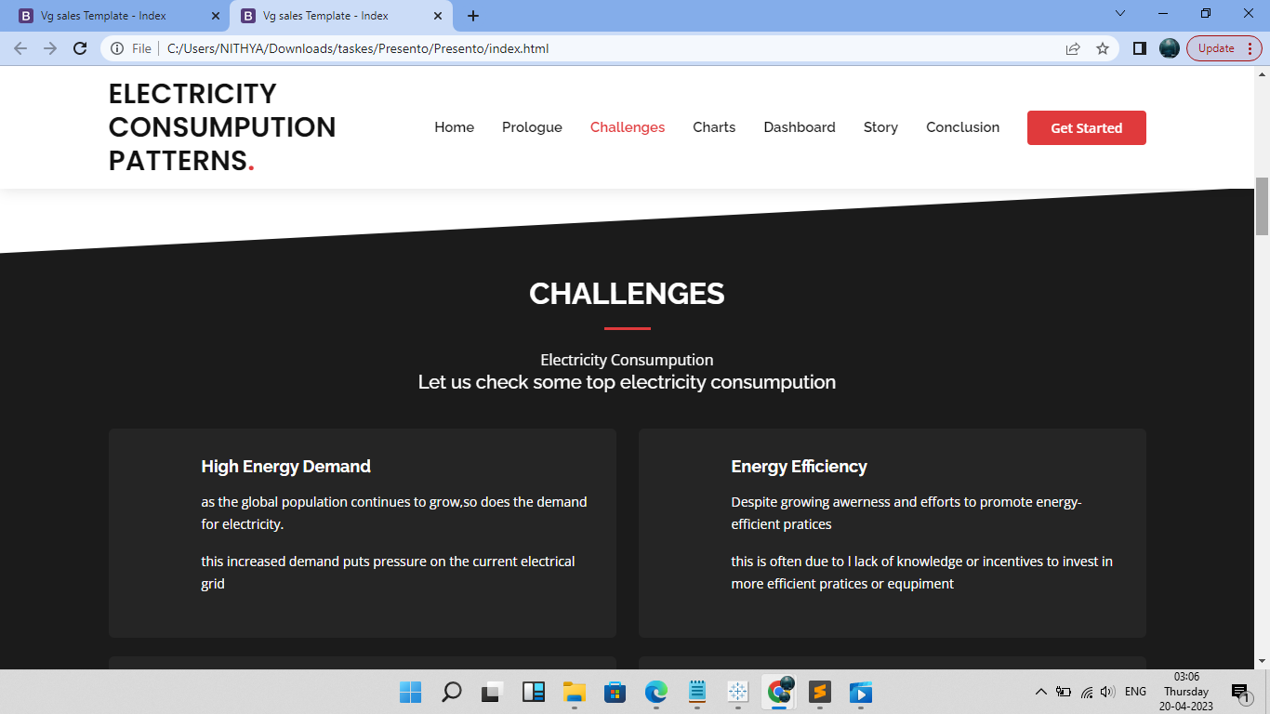

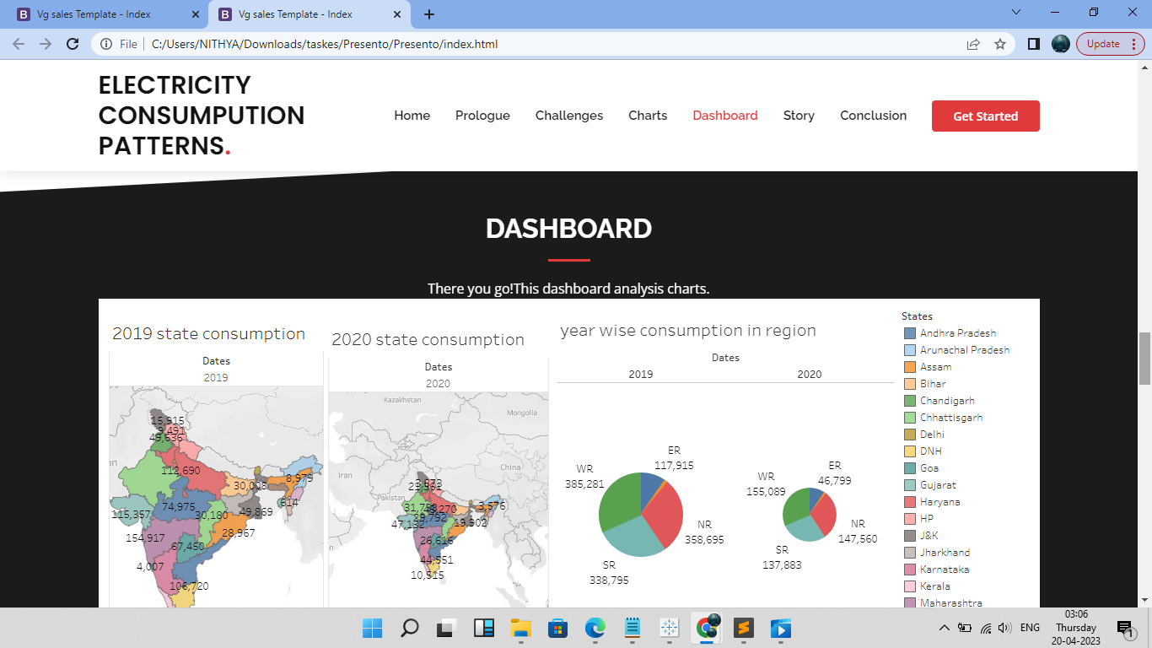

8.APPENTIX

Html source code:

<!DOCTYPE html>

<html lang="en">

<head>

<meta charset="utf-8">

<meta content="width=device-width, initial-scale=1.0" name="viewport">

<title>Vg sales Template - Index</title>

<meta content="" name="description">

<meta content="" name="keywords">

<!-- Favicons -->

<link href="assets/img/favicon.png" rel="icon">

<link href="assets/img/apple-touch-icon.png" rel="apple-touch-icon">

<!-- Google Fonts -->

<link href="https://fonts.googleapis.com/css?family=Open+Sans:300,300i,400,400i,600,600i,700,700i|Raleway:300,300i,400,400i,500,500i,600,600i,700,700i|Poppins:300,300i,400,400i,500,500i,600,600i,700,700i" rel="stylesheet">

<!-- Vendor CSS Files -->

<link href="assets/vendor/aos/aos.css" rel="stylesheet">

<link href="assets/vendor/bootstrap/css/bootstrap.min.css" rel="stylesheet">

<link href="assets/vendor/bootstrap-icons/bootstrap-icons.css" rel="stylesheet">

<link href="assets/vendor/boxicons/css/boxicons.min.css" rel="stylesheet">

<link href="assets/vendor/glightbox/css/glightbox.min.css" rel="stylesheet">

<link href="assets/vendor/remixicon/remixicon.css" rel="stylesheet">

<link href="assets/vendor/swiper/swiper-bundle.min.css" rel="stylesheet">

<!-- Template Main CSS File -->

<link href="assets/css/style.css" rel="stylesheet">

<!-- =======================================================

* Template Name: Presento

* Updated: Mar 10 2023 with Bootstrap v5.2.3

* Template URL: https://bootstrapmade.com/presento-bootstrap-corporate-template/

* Author: BootstrapMade.com

* License: https://bootstrapmade.com/license/

======================================================== -->

</head>

<body>

<!-- ======= Header ======= -->

<header id="header" class="fixed-top d-flex align-items-center">

<div class="container d-flex align-items-center">

<h1 class="logo me-auto"><a href="index.html">ELECTRICITY CONSUMPUTION PATTERNS<span>.</span></a></h1>

<!-- Uncomment below if you prefer to use an image logo -->

<!-- <a href="index.html" class="logo me-auto"><img src="assets/img/logo.png" alt=""></a>-->

<nav id="navbar" class="navbar order-last order-lg-0">

<ul>

<li><a class="nav-link scrollto active" href="#hero">Home</a></li>

<li><a class="nav-link scrollto" href="#about">Prologue</a></li>

<li><a class="nav-link scrollto" href="#services">Challenges</a></li>

<li><a class="nav-link scrollto " href="#portfolio">Charts</a></li>

<li><a class="nav-link scrollto" href="#pricing">Dashboard</a></li>

<li><a class="nav-link scrollto" href="#team">Story</a></li>

<li><a class="nav-link scrollto" href="#conclusion">Conclusion</a></li>

</ul>

<i class="bi bi-list mobile-nav-toggle"></i>

</nav><!-- .navbar -->

<a href="#about" class="get-started-btn scrollto">Get Started</a>

</div>

</header><!-- End Header -->

<!-- ======= Hero Section ======= -->

<section id="hero" class="d-flex align-items-center">

<div class="container" data-aos="zoom-out" data-aos-delay="100">

<div class="row">

<div class="col-xl-6">

<h1>A Tableau Presentation</h1>

<a href="#about" class="btn-get-started scrollto">Get Started</a>

</div>

</div>

</div>

</section><!-- End Hero -->

<main id="main">

<!-- ======= Prologue Section ======= -->

<section id="about" class="about section-bg">

<div class="container" data-aos="fade-up">

<div class="row no-gutters">

<div class="content col-xl-5 d-flex align-items-stretch">

<div class="content">

<p>

the production and consumption of electricity have a significant impact on the environment

</p>

<p>

finding ways to reduce this impact while still meeting energy demands is a major challenge for goverments and bussiness alike

</p>

</div>

</div>

</div><!-- End .content-->

</div>

</div>

</div>

</section><!-- End Prologue Section -->

<!-- ======= Challenges Section ======= -->

<section id="services" class="services section-bg ">

<div class="container" data-aos="fade-up">

<div class="section-title">

<h2>CHALLENGES</h2>

<p>Electricity Consumpution</p>

<h5>Let us check some top electricity consumpution</h5>

</div>

<div class="row">

<div class="col-md-6">

<div class="icon-box" data-aos="fade-up" data-aos-delay="100">

<h4><a href="#">High Energy Demand</a></h4>

<p>as the global population continues to grow,so does the demand for electricity.</p>

<p>this increased demand puts pressure on the current electrical grid</p>

</div>

</div>

<div class="col-md-6 mt-4 mt-md-0">

<div class="icon-box" data-aos="fade-up" data-aos-delay="200">

<h4><a href="#">Energy Efficiency</a></h4>

<p>Despite growing awerness and efforts to promote energy-efficient pratices</p>

<p>this is often due to l lack of knowledge or incentives to invest in more efficient pratices or equpiment</p>

</div>

</div>

<div class="col-md-6 mt-4 mt-md-0">

<div class="icon-box" data-aos="fade-up" data-aos-delay="300">

<h4><a href="#">limited renewable energy sources</a></h4>

<p>while renewable energy sources such as solar and wind power are becoming more common</p>

<p>the limited availability of these sources posses challenges for acheiving a sustainable energy future</p>

</div>

</div>

<div class="col-md-6 mt-4 mt-md-0">

<div class="icon-box" data-aos="fade-up" data-aos-delay="400">

<h4><a href="#"> </a></h4>

<p> </p>

<p> </p>

</div>

</div>

<div class="col-md-6 mt-4 mt-md-0">

<div class="icon-box" data-aos="fade-up" data-aos-delay="500">

<h4><a href="#"> </a></h4>

<p> </p>

<p> </p>

</div>

</div>

<div class="col-md-6 mt-4 mt-md-0">

<div class="icon-box" data-aos="fade-up" data-aos-delay="600">

<h4><a href="#"> </a></h4>

<p> </p>

<p> </p>

</div>

</div>

</div>

</div>

</section><!-- End Challenges Section -->

<!-- ======= Charts Section ======= -->

<section id="portfolio" class="portfolio">

<div class="container" data-aos="fade-up">

<div class="section-title">

<h2>ANALYSIS CHARTS</h2>

<p>electricity consumpution pattern</p>

</div>

<div class="row" data-aos="fade-up" data-aos-delay="100">

<div class="col-lg-12 d-flex justify-content-center">

<ul id="portfolio-flters">

<li data-filter="*" class="filter-active">ALL</li>

<li data-filter=".filter-app">SALES</li>

<li data-filter=".filter-card">GENRE</li>

<li data-filter=".filter-web">PUBLISHERS</li>

</ul>

</div>

</div>

<div class="row portfolio-container" data-aos="fade-up" data-aos-delay="200">

<div class="col-lg-4 col-md-6 portfolio-item filter-app">

<div class="portfolio-wrap">

<img src="assets/img/charts/Sheet 3.png" class="img-fluid" alt="">

<div class="portfolio-info">

<h4>Sales 1</h4>

<p>Sales</p>

<div class="portfolio-links">

<a href="assets/img/charts/Sheet 3.png" data-gallery="portfolioGallery" class="portfolio-lightbox" title="App 1"><i class="bx bx-plus"></i></a>

</div>

</div>

</div>

</div>

<div class="col-lg-4 col-md-6 portfolio-item filter-web">

<div class="portfolio-wrap">

<img src="assets/img/charts/Sheet 4.png" class="img-fluid" alt="">

<div class="portfolio-info">

<h4>Publisher 1</h4>

<p>Publishers</p>

<div class="portfolio-links">

<a href="assets/img/charts/Sheet 4.png" data-gallery="portfolioGallery" class="portfolio-lightbox" title= "Web 3"><i class="bx bx-plus"></i></a>

</div>

</div>

</div>

</div>

<div class="col-lg-4 col-md-6 portfolio-item filter-app">

<div class="portfolio-wrap">

<img src="assets/img/charts/Sheet 1.png" class="img-fluid" alt="">

<div class="portfolio-info">

<h4>Sales 2</h4>

<p>Sales</p>

<div class="portfolio-links">

<a href="assets/img/charts/Sheet 1.png" data-gallery="portfolioGallery" class="portfolio-lightbox" title="App 2"><i class="bx bx-plus"></i></a>

</div>

</div>

</div>

</div>

<div class="col-lg-4 col-md-6 portfolio-item filter-card">

<div class="portfolio-wrap">

<img src="assets/img/charts/Sheet 5.png" class="img-fluid" alt="">

<div class="portfolio-info">

<h4>Genre 1</h4>

<p>Genre</p>

<div class="portfolio-links">

<a href="assets/img/charts/Sheet 5.png" data-gallery="portfolioGallery" class="portfolio-lightbox" title="Card 2"><i class="bx bx-plus"></i></a>

</div>

</div>

</div>

</div>

<div class="col-lg-4 col-md-6 portfolio-item filter-web">

<div class="portfolio-wrap">

<img src="assets/img/charts/Sheet 13.png" class="img-fluid" alt="">

<div class="portfolio-info">

<h4>Publisher 2</h4>

<p>Publisher</p>

<div class="portfolio-links">

<a href="assets/img/charts/Sheet 13.png" data-gallery="portfolioGallery" class="portfolio-lightbox" title="Web 2"><i class="bx bx-plus"></i></a>

</div>

</div>

</div>

</div>

<div class="col-lg-4 col-md-6 portfolio-item filter-app">

<div class="portfolio-wrap">

<img src="assets/img/charts/Sheet 12.png" class="img-fluid" alt="">

<div class="portfolio-info">

<h4>Sales 3</h4>

<p>Sales</p>

<div class="portfolio-links">

<a href="assets/img/charts/Sheet 12.png" data-gallery="portfolioGallery" class="portfolio-lightbox" title="App 3"><i class="bx bx-plus"></i></a>

</div>

</div>

</div>

</div>

<div class="col-lg-4 col-md-6 portfolio-item filter-card">

<div class="portfolio-wrap">

<img src="assets/img/charts/Sheet 2.png" class="img-fluid" alt="">

<div class="portfolio-info">

<h4>Genre 2</h4>

<p>Genre</p>

<div class="portfolio-links">

<a href="assets/img/charts/Sheet 2.png" data-gallery="portfolioGallery" class="portfolio-lightbox" title="Card 1"><i class="bx bx-plus"></i></a>

</div>

</div>

</div>

</div>

<div class="col-lg-4 col-md-6 portfolio-item filter-card">

<div class="portfolio-wrap">

<img src="assets/img/charts/Sheet 11.png" class="img-fluid" alt="">

<div class="portfolio-info">

<h4>Genre 3</h4>

<p>Genre</p>

<div class="portfolio-links">

<a href="assets/img/charts/Sheet 11.png" data-gallery="portfolioGallery" class="portfolio-lightbox" title="Card 3"><i class="bx bx-plus"></i></a>

</div>

</div>

</div>

</div>

<div class="col-lg-4 col-md-6 portfolio-item filter-web">

<div class="portfolio-wrap">

<img src="assets/img/charts/Sheet 14.png" class="img-fluid" alt="">

<div class="portfolio-info">

<h4>Publisher 3</h4>

<p>Publisher</p>

<div class="portfolio-links">

<a href="assets/img/charts/Sheet 14.png" data-gallery="portfolioGallery" class="portfolio-lightbox" title="Web 3"><i class="bx bx-plus"></i></a>

</div>

</div>

</div>

</div>

</div>

</div>

</section><!-- End Charts Section -->

<!-- ======= Dashboard Section ======= -->

<section id="pricing" class="pricing section-bg">

<div class="container" data-aos="fade-up">

<div class="section-title">

<h2>DASHBOARD</h2>

<p>There you go!This dashboard analysis charts.</p>

<div>

<div>

<div class='tableauPlaceholder' id='viz1681979112533' style='position: relative'><noscript><a href='#'><img alt='Dashboard 1 ' src='https:&#47;&#47;public.tableau.com&#47;static&#47;images&#47;56&#47;567_16818422521380&#47;Dashboard1&#47;1_rss.png' style='border: none' /></a></noscript><object class='tableauViz' style='display:none;'><param name='host_url' value='https%3A%2F%2Fpublic.tableau.com%2F' /> <param name='embed_code_version' value='3' /> <param name='site_root' value='' /><param name='name' value='567_16818422521380&#47;Dashboard1' /><param name='tabs' value='no' /><param name='toolbar' value='yes' /><param name='static_image' value='https:&#47;&#47;public.tableau.com&#47;static&#47;images&#47;56&#47;567_16818422521380&#47;Dashboard1&#47;1.png' /> <param name='animate_transition' value='yes' /><param name='display_static_image' value='yes' /><param name='display_spinner' value='yes' /><param name='display_overlay' value='yes' /><param name='display_count' value='yes' /><param name='language' value='en-US' /><param name='filter' value='publish=yes' /></object></div> <script type='text/javascript'> var divElement = document.getElementById('viz1681979112533'); var vizElement = divElement.getElementsByTagName('object')[0]; if ( divElement.offsetWidth > 800 ) { vizElement.style.width='100%';vizElement.style.height=(divElement.offsetWidth*0.75)+'px';} else if ( divElement.offsetWidth > 500 ) { vizElement.style.width='100%';vizElement.style.height=(divElement.offsetWidth*0.75)+'px';} else { vizElement.style.width='100%';vizElement.style.height='1827px';} var scriptElement = document.createElement('script'); scriptElement.src = 'https://public.tableau.com/javascripts/api/viz_v1.js'; vizElement.parentNode.insertBefore(scriptElement, vizElement); </script>

</div>

</div>

</div>

</section><!-- End Dashboard Section -->

<!-- ======= Story Section ======= -->

<section id="team" class="team section-bg">

<div class="container" data-aos="fade-up">

<div class="section-title">

<h2>STORY</h2>

<p>Stories of the Charts</p>

<div>

<div>

<div class='tableauPlaceholder' id='viz1681979308707' style='position: relative'><noscript><a href='#'><img alt='story on electricity consumption in india ' src='https:&#47;&#47;public.tableau.com&#47;static&#47;images&#47;56&#47;567_16818422521380&#47;storyonelectricityconsumptioninindia&#47;1_rss.png' style='border: none' /></a></noscript><object class='tableauViz' style='display:none;'><param name='host_url' value='https%3A%2F%2Fpublic.tableau.com%2F' /> <param name='embed_code_version' value='3' /> <param name='site_root' value='' /><param name='name' value='567_16818422521380&#47;storyonelectricityconsumptioninindia' /><param name='tabs' value='no' /><param name='toolbar' value='yes' /><param name='static_image' value='https:&#47;&#47;public.tableau.com&#47;static&#47;images&#47;56&#47;567_16818422521380&#47;storyonelectricityconsumptioninindia&#47;1.png' /> <param name='animate_transition' value='yes' /><param name='display_static_image' value='yes' /><param name='display_spinner' value='yes' /><param name='display_overlay' value='yes' /><param name='display_count' value='yes' /><param name='language' value='en-US' /><param name='filter' value='publish=yes' /></object></div> <script type='text/javascript'> var divElement = document.getElementById('viz1681979308707'); var vizElement = divElement.getElementsByTagName('object')[0]; vizElement.style.width='1016px';vizElement.style.height='991px'; var scriptElement = document.createElement('script'); scriptElement.src = 'https://public.tableau.com/javascripts/api/viz_v1.js'; vizElement.parentNode.insertBefore(scriptElement, vizElement); </script>

</div>

</div>

</section><!-- End Team Section -->

</main><!-- End #main -->

<!-- Conclusion Section -->

<section id="conclusion" class="conclusion section-bg">

<div class="container" data-aos="fade-up">

<div class="section-title">

<h2>CONCLUSION</h2></div>

<div class="content">

<ul>

<li><a href="">Conclusion-1</a></li>

<p>By the above data we can say that action games on DC or playstation for that matter are the most popular and the ones responsible for maximum sales all over the globe.</p>

<li><a href="">Conclusion-2</a></li>

<p>Also as these games are so abundant and popular(ranking wise),variation in the sales of one or two such games would not cause significant change in the overall sales.</p>

<li><a href="">Conclusion-3</a></li>

<p>Well,there are lots of efforts going into creating a single game and due to modern era mobile games other platforms are getting deprived of the attention which had created a lot of awesome experiences for the gamers from 1980-2020.</p>

</ul>

</div>

<!--End Conclusion Section-->

<a href="#" class="back-to-top d-flex align-items-center justify-content-center"><i class="bi bi-arrow-up-short"></i></a>

<!-- Vendor JS Files -->

<script src="assets/vendor/purecounter/purecounter_vanilla.js"></script>

<script src="assets/vendor/aos/aos.js"></script>

<script src="assets/vendor/bootstrap/js/bootstrap.bundle.min.js"></script>

<script src="assets/vendor/glightbox/js/glightbox.min.js"></script>

<script src="assets/vendor/isotope-layout/isotope.pkgd.min.js"></script>

<script src="assets/vendor/swiper/swiper-bundle.min.js"></script>

<script src="assets/vendor/php-email-form/validate.js"></script>

<!-- Template Main JS File -->

<script src="assets/js/main.js"></script>

</body>

</html>

css code:

/**

* Template Name: Presento

* Updated: Mar 10 2023 with Bootstrap v5.2.3

* Template URL: https://bootstrapmade.com/presento-bootstrap-corporate-template/

* Author: BootstrapMade.com

* License: https://bootstrapmade.com/license/

*/

/*--------------------------------------------------------------

# General

--------------------------------------------------------------*/

body {

font-family: "Open Sans", sans-serif;

color: #444444;

}

a {

color: #e03a3c;

text-decoration: none;

}

a:hover {

color: #e76668;

text-decoration: none;

}

h1,

h2,

h3,

h4,

h5,

h6 {

font-family: "Raleway", sans-serif;

}

/*--------------------------------------------------------------

# Back to top button

--------------------------------------------------------------*/

.back-to-top {

position: fixed;

visibility: hidden;

opacity: 0;

right: 15px;

bottom: 15px;

z-index: 996;

background: #e03a3c;

width: 40px;

height: 40px;

border-radius: 4px;

transition: all 0.4s;

}

.back-to-top i {

font-size: 28px;

color: #fff;

line-height: 0;

}

.back-to-top:hover {

background: #e65d5f;

color: #fff;

}

.back-to-top.active {

visibility: visible;

opacity: 1;

}

/*--------------------------------------------------------------

# Disable aos animation delay on mobile devices

--------------------------------------------------------------*/

@media screen and (max-width: 768px) {

[data-aos-delay] {

transition-delay: 0 !important;

}

}

/*--------------------------------------------------------------

# Header

--------------------------------------------------------------*/

#header {

background: #fff;

transition: all 0.5s;

z-index: 997;

padding: 20px 0;

}

#header.header-scrolled {

padding: 12px 0;

box-shadow: 0px 2px 15px rgba(0, 0, 0, 0.1);

}

#header .logo {

font-size: 30px;

margin: 0;

padding: 0;

font-weight: 600;

font-family: "Poppins", sans-serif;

}

#header .logo a {

color: #111111;

}

#header .logo a span {

color: #e03a3c;

}

#header .logo img {

max-height: 40px;

}

/*--------------------------------------------------------------

# Get Startet Button

--------------------------------------------------------------*/

.get-started-btn {

margin-left: 30px;

background: #e03a3c;

color: #fff;

border-radius: 4px;

padding: 8px 25px;

white-space: nowrap;

transition: 0.3s;

font-size: 14px;

font-weight: 600;

display: inline-block;

}

.get-started-btn:hover {

background: #111111;

color: #fff;

}

@media (max-width: 992px) {

.get-started-btn {

margin: 0 15px 0 0;

padding: 6px 18px;

}

}

/*--------------------------------------------------------------

# Navigation Menu

--------------------------------------------------------------*/

/**

* Desktop Navigation

*/

.navbar {

padding: 0;

}

.navbar ul {

margin: 0;

padding: 0;

display: flex;

list-style: none;

align-items: center;

}

.navbar li {

position: relative;

}

.navbar a,

.navbar a:focus {

display: flex;

align-items: center;

justify-content: space-between;

padding: 10px 0 10px 30px;

font-family: "Raleway", sans-serif;

font-size: 15px;

font-weight: 600;

color: #111111;

white-space: nowrap;

transition: 0.3s;

}

.navbar a i,

.navbar a:focus i {

font-size: 12px;

line-height: 0;

margin-left: 5px;

}

.navbar a:hover,

.navbar .active,

.navbar .active:focus,

.navbar li:hover>a {

color: #e03a3c;

}

.navbar .dropdown ul {

display: block;

position: absolute;

left: 30px;

top: calc(100% + 30px);

margin: 0;

padding: 10px 0;

z-index: 99;

opacity: 0;

visibility: hidden;

background: #fff;

box-shadow: 0px 0px 30px rgba(127, 137, 161, 0.25);

transition: 0.3s;

}

.navbar .dropdown ul li {

min-width: 200px;

}

.navbar .dropdown ul a {

padding: 10px 20px;

font-size: 14px;

}

.navbar .dropdown ul a i {

font-size: 12px;

}

.navbar .dropdown ul a:hover,

.navbar .dropdown ul .active:hover,

.navbar .dropdown ul li:hover>a {

color: #e03a3c;

}

.navbar .dropdown:hover>ul {

opacity: 1;

top: 100%;

visibility: visible;

}

.navbar .dropdown .dropdown ul {

top: 0;

left: calc(100% - 30px);

visibility: hidden;

}

.navbar .dropdown .dropdown:hover>ul {

opacity: 1;

top: 0;

left: 100%;

visibility: visible;

}

@media (max-width: 1366px) {

.navbar .dropdown .dropdown ul {

left: -90%;

}

.navbar .dropdown .dropdown:hover>ul {

left: -100%;

}

}

/**

* Mobile Navigation

*/

.mobile-nav-toggle {

color: #111111;

font-size: 28px;

cursor: pointer;

display: none;

line-height: 0;

transition: 0.5s;

}

.mobile-nav-toggle.bi-x {

color: #fff;

}

@media (max-width: 991px) {

.mobile-nav-toggle {

display: block;

}

.navbar ul {

display: none;

}

}

.navbar-mobile {

position: fixed;

overflow: hidden;

top: 0;

right: 0;

left: 0;

bottom: 0;

background: rgba(0, 0, 0, 0.9);

transition: 0.3s;

z-index: 999;

}

.navbar-mobile .mobile-nav-toggle {

position: absolute;

top: 15px;

right: 15px;

}

.navbar-mobile ul {

display: block;

position: absolute;

top: 55px;

right: 15px;

bottom: 15px;

left: 15px;

padding: 10px 0;

background-color: #fff;

overflow-y: auto;

transition: 0.3s;

}

.navbar-mobile a,

.navbar-mobile a:focus {

padding: 10px 20px;

font-size: 15px;

color: #111111;

}

.navbar-mobile a:hover,

.navbar-mobile .active,

.navbar-mobile li:hover>a {

color: #e03a3c;

}

.navbar-mobile .getstarted,

.navbar-mobile .getstarted:focus {

margin: 15px;

}

.navbar-mobile .dropdown ul {

position: static;

display: none;

margin: 10px 20px;

padding: 10px 0;

z-index: 99;

opacity: 1;

visibility: visible;

background: #fff;

box-shadow: 0px 0px 30px rgba(127, 137, 161, 0.25);

}

.navbar-mobile .dropdown ul li {

min-width: 200px;

}

.navbar-mobile .dropdown ul a {

padding: 10px 20px;

}

.navbar-mobile .dropdown ul a i {

font-size: 12px;

}

.navbar-mobile .dropdown ul a:hover,

.navbar-mobile .dropdown ul .active:hover,

.navbar-mobile .dropdown ul li:hover>a {

color: #e03a3c;

}

.navbar-mobile .dropdown>.dropdown-active {

display: block;

}

/*--------------------------------------------------------------

# Hero Section

--------------------------------------------------------------*/

#hero {

width: 100%;

height: 100vh;

background: #37517e;

background-size: cover;

position: relative;

padding-top: 82px;

}

#hero:before {

content: "";

background: rgba(0, 0, 0, 0.6);

position: absolute;

bottom: 0;

top: 0;

left: 0;

right: 0;

}

#hero h1 {

margin: 0;

font-size: 48px;

font-weight: 700;

color: #fff;

}

#hero h2 {

color: #fff;

margin: 10px 0 0 0;

font-size: 24px;

}

#hero .btn-get-started {

font-family: "Raleway", sans-serif;

font-weight: 500;

font-size: 16px;

letter-spacing: 1px;

display: inline-block;

padding: 10px 30px;

border-radius: 4px;

transition: 0.5s;

margin-top: 30px;

color: #fff;

background: #e03a3c;

border: 2px solid #e03a3c;

}

#hero .btn-get-started:hover {

background: transparent;

border-color: #fff;

}

@media (max-width: 768px) {

#hero {

text-align: center;

padding-top: 58px;

}

#hero h1 {

font-size: 28px;

}

#hero h2 {

font-size: 18px;

line-height: 24px;

}

}

@media (max-height: 500px) {

#hero {

height: 120vh;

}

}

/*--------------------------------------------------------------

# Sections General

--------------------------------------------------------------*/

section {

padding: 60px 0;

overflow: hidden;

position: relative;

}

.section-title {

text-align: center;

padding-bottom: 30px;

position: relative;

}

.section-title h2 {

font-size: 32px;

font-weight: bold;

text-transform: uppercase;

margin-bottom: 20px;

padding-bottom: 20px;

position: relative;

}

.section-title h2::after {

content: "";

position: absolute;

display: block;

width: 50px;

height: 3px;

background: #e03a3c;

bottom: 0;

left: calc(50% - 25px);

}

.section-title p {

margin-bottom: 0;

}

.section-bg {

padding: 120px 0;

color: #fff;

}

.section-bg:before {

content: "";

background: #1b1b1b;

position: absolute;

bottom: 60px;

top: 60px;

left: 0;

right: 0;

transform: skewY(-3deg);

}

/*--------------------------------------------------------------

# Breadcrumbs

--------------------------------------------------------------*/

.breadcrumbs {

padding: 15px 0;

background: #2b2b2b;

min-height: 40px;

margin-top: 82px;

color: #fff;

}

.breadcrumbs h2 {

font-size: 28px;

font-weight: 500;

}

.breadcrumbs ol {

display: flex;

flex-wrap: wrap;

list-style: none;

padding: 0 0 10px 0;

margin: 0;

font-size: 14px;

}

.breadcrumbs ol a {

color: #aaaaaa;

}

.breadcrumbs ol a:hover {

color: #fff;

transition: 0.3s;

}

.breadcrumbs ol li+li {

padding-left: 10px;

}

.breadcrumbs ol li+li::before {

display: inline-block;

padding-right: 10px;

color: #e03a3c;

content: "/";

}

/*--------------------------------------------------------------

# Clients

--------------------------------------------------------------*/

.clients .swiper-pagination {

margin-top: 20px;

position: relative;

}

.clients .swiper-pagination .swiper-pagination-bullet {

width: 12px;

height: 12px;

background-color: #fff;

opacity: 1;

border: 1px solid #e03a3c;

}

.clients .swiper-pagination .swiper-pagination-bullet-active {

background-color: #e03a3c;

}

.clients .swiper-slide img {

opacity: 0.5;

transition: 0.3s;

filter: grayscale(100);

}

.clients .swiper-slide img:hover {

opacity: 1;

filter: none;

}

/*--------------------------------------------------------------

# About

--------------------------------------------------------------*/

.about .container {

position: relative;

z-index: 10;

}

.about .content {

padding: 30px 30px 30px 0;

}

.about .content h3 {

font-weight: 700;

font-size: 34px;

margin-bottom: 30px;

}

.about .content p {

margin-bottom: 30px;

}

.about .content .about-btn {

padding: 8px 30px 9px 30px;

color: #fff;

border-radius: 50px;

transition: 0.3s;

text-transform: uppercase;

font-weight: 600;

font-size: 13px;

display: inline-flex;

align-items: center;

border: 2px solid #e03a3c;

}

.about .content .about-btn i {

font-size: 16px;

padding-left: 5px;

}

.about .content .about-btn:hover {

background: #e35052;

background: #e03a3c;

}

.about .icon-boxes .icon-box {

margin-top: 30px;

}

.about .icon-boxes .icon-box i {

font-size: 40px;

color: #e03a3c;

margin-bottom: 10px;

}

.about .icon-boxes .icon-box h4 {

font-size: 20px;

font-weight: 700;

margin: 0 0 10px 0;

}

.about .icon-boxes .icon-box p {

font-size: 15px;

color: #848484;

}

@media (max-width: 1200px) {

.about .content {

padding-right: 0;

}

}

@media (max-width: 768px) {

.about {

text-align: center;

}

}

/*--------------------------------------------------------------

# Counts

--------------------------------------------------------------*/

.counts {

padding-top: 80px;

}

.counts .count-box {

padding: 30px 30px 25px 30px;

width: 100%;

position: relative;

text-align: center;

box-shadow: 0px 2px 35px rgba(0, 0, 0, 0.06);

border-radius: 4px;

}

.counts .count-box i {

position: absolute;

width: 54px;

height: 54px;

top: -27px;

left: 50%;

transform: translateX(-50%);

font-size: 24px;

background: #fff;

color: #e03a3c;

border-radius: 50px;

border: 2px solid #fff;

box-shadow: 0px 2px 25px rgba(0, 0, 0, 0.1);

display: inline-flex;

align-items: center;

justify-content: center;

}

.counts .count-box span {

font-size: 36px;

display: block;

font-weight: 700;

color: #111111;

}

.counts .count-box p {

padding: 0;

margin: 0;

font-family: "Raleway", sans-serif;

font-size: 14px;

}

/*--------------------------------------------------------------

# Tabs

--------------------------------------------------------------*/

.tabs .nav-tabs {

border: 0;

}

.tabs .nav-link {

border: 1px solid #b9b9b9;

padding: 15px;

transition: 0.3s;

color: #111111;

border-radius: 0;

display: flex;

align-items: center;

justify-content: center;

cursor: pointer;

}

.tabs .nav-link i {

padding-right: 15px;

font-size: 48px;

}

.tabs .nav-link h4 {

font-size: 18px;

font-weight: 600;

margin: 0;

}

.tabs .nav-link:hover {

color: #e03a3c;

}

.tabs .nav-link.active {

background: #e03a3c;

color: #fff;

border-color: #e03a3c;

}

@media (max-width: 768px) {

.tabs .nav-link i {

padding: 0;

line-height: 1;

font-size: 36px;

}

}

@media (max-width: 575px) {

.tabs .nav-link {

padding: 15px;

}

.tabs .nav-link i {

font-size: 24px;

}

}

.tabs .tab-content {

margin-top: 30px;

}

.tabs .tab-pane h3 {

font-weight: 600;

font-size: 26px;

}

.tabs .tab-pane ul {

list-style: none;

padding: 0;

}

.tabs .tab-pane ul li {

padding-bottom: 10px;

}

.tabs .tab-pane ul i {

font-size: 20px;

padding-right: 4px;

color: #e03a3c;

}

.tabs .tab-pane p:last-child {

margin-bottom: 0;

}

/*--------------------------------------------------------------

# Services

--------------------------------------------------------------*/

.services .icon-box {

margin-bottom: 20px;

padding: 30px;

border-radius: 6px;

background: #252525;

transition: 0.3s;

}

.services .icon-box:hover {

background: #2b2b2b;

}

.services .icon-box i {

float: left;

color: #e03a3c;

font-size: 40px;

line-height: 0;

}

.services .icon-box h4 {

margin-left: 70px;

font-weight: 700;

margin-bottom: 15px;

font-size: 18px;

}

.services .icon-box h4 a {

color: #fff;

transition: 0.3s;

}

.services .icon-box h4 a:hover {

text-decoration: underline;

}

.services .icon-box .icon-box:hover h4 a {

color: #e03a3c;

}

.services .icon-box p {

margin-left: 70px;

line-height: 24px;

font-size: 14px;

}

/*--------------------------------------------------------------

# Portfolio

--------------------------------------------------------------*/

.portfolio .portfolio-item {

margin-bottom: 30px;

}

.portfolio #portfolio-flters {

padding: 0;

margin: 0 auto 20px auto;

list-style: none;

text-align: center;

}

.portfolio #portfolio-flters li {

cursor: pointer;

display: inline-block;

padding: 8px 15px 10px 15px;

font-size: 14px;

font-weight: 600;

line-height: 1;

text-transform: uppercase;

color: #444444;

margin-bottom: 5px;

transition: all 0.3s ease-in-out;

border-radius: 3px;

}

.portfolio #portfolio-flters li:hover,

.portfolio #portfolio-flters li.filter-active {

color: #fff;

background: #e03a3c;

}

.portfolio #portfolio-flters li:last-child {

margin-right: 0;

}

.portfolio .portfolio-wrap {

transition: 0.3s;

position: relative;

overflow: hidden;

z-index: 1;

background: rgba(17, 17, 17, 0.6);

}

.portfolio .portfolio-wrap::before {

content: "";

background: rgba(17, 17, 17, 0.6);

position: absolute;

left: 0;

right: 0;

top: 0;

bottom: 0;

transition: all ease-in-out 0.3s;

z-index: 2;

opacity: 0;

}

.portfolio .portfolio-wrap img {

transition: all ease-in-out 0.3s;

}

.portfolio .portfolio-wrap .portfolio-info {

opacity: 0;

position: absolute;

top: 0;

left: 0;

right: 0;

bottom: 0;

z-index: 3;

transition: all ease-in-out 0.3s;

display: flex;

flex-direction: column;

justify-content: flex-end;

align-items: flex-start;

padding: 20px;

}

.portfolio .portfolio-wrap .portfolio-info h4 {

font-size: 20px;

color: #fff;

font-weight: 600;

}

.portfolio .portfolio-wrap .portfolio-info p {

color: rgba(255, 255, 255, 0.7);

font-size: 14px;

text-transform: uppercase;

padding: 0;

margin: 0;

font-style: italic;

}

.portfolio .portfolio-wrap .portfolio-links {

text-align: center;

z-index: 4;

}

.portfolio .portfolio-wrap .portfolio-links a {

color: rgba(255, 255, 255, 0.4);

margin: 0 5px 0 0;

font-size: 28px;

display: inline-block;

transition: 0.3s;

}

.portfolio .portfolio-wrap .portfolio-links a:hover {

color: #fff;

}

.portfolio .portfolio-wrap:hover::before {

opacity: 1;

}

.portfolio .portfolio-wrap:hover img {

transform: scale(1.2);

}

.portfolio .portfolio-wrap:hover .portfolio-info {

opacity: 1;

}

/*--------------------------------------------------------------

# Portfolio Details

--------------------------------------------------------------*/

.portfolio-details {

padding-top: 40px;

}

.portfolio-details .portfolio-details-slider img {

width: 100%;

}

.portfolio-details .portfolio-details-slider .swiper-pagination {

margin-top: 20px;

position: relative;

}

.portfolio-details .portfolio-details-slider .swiper-pagination .swiper-pagination-bullet {

width: 12px;

height: 12px;

background-color: #fff;

opacity: 1;

border: 1px solid #e03a3c;

}

.portfolio-details .portfolio-details-slider .swiper-pagination .swiper-pagination-bullet-active {

background-color: #e03a3c;

}

.portfolio-details .portfolio-info {

padding: 30px;

box-shadow: 0px 0 30px rgba(17, 17, 17, 0.08);

}

.portfolio-details .portfolio-info h3 {

font-size: 22px;

font-weight: 700;

margin-bottom: 20px;

padding-bottom: 20px;

border-bottom: 1px solid #eee;

}

.portfolio-details .portfolio-info ul {

list-style: none;

padding: 0;

font-size: 15px;

}

.portfolio-details .portfolio-info ul li+li {

margin-top: 10px;

}

.portfolio-details .portfolio-description {

padding-top: 30px;

}

.portfolio-details .portfolio-description h2 {

font-size: 26px;

font-weight: 700;

margin-bottom: 20px;

}

.portfolio-details .portfolio-description p {

padding: 0;

}

/*--------------------------------------------------------------

# Testimonials

--------------------------------------------------------------*/

.testimonials .testimonials-carousel,

.testimonials .testimonials-slider {

overflow: hidden;

}

.testimonials .testimonial-item {

box-sizing: content-box;

padding: 30px;

margin: 30px 15px;

min-height: 200px;

box-shadow: 0px 2px 12px rgba(0, 0, 0, 0.08);

position: relative;

background: #fff;

border-radius: 15px;

}

.testimonials .testimonial-item .testimonial-img {

width: 90px;

border-radius: 10px;

border: 6px solid #fff;

float: left;

margin: 0 10px 0 0;

}

.testimonials .testimonial-item h3 {

font-size: 18px;

font-weight: bold;

margin: 25px 0 5px 0;

color: #111;

}

.testimonials .testimonial-item h4 {

font-size: 14px;

color: #999;

margin: 0;

}

.testimonials .testimonial-item .quote-icon-left,

.testimonials .testimonial-item .quote-icon-right {

color: #fceaea;

font-size: 26px;

}

.testimonials .testimonial-item .quote-icon-left {

display: inline-block;

left: -5px;

position: relative;

}

.testimonials .testimonial-item .quote-icon-right {

display: inline-block;

right: -5px;

position: relative;

top: 10px;

}

.testimonials .testimonial-item p {

font-style: italic;

margin: 30px auto 15px auto;

}

.testimonials .swiper-pagination {

margin-top: 20px;

position: relative;

}

.testimonials .swiper-pagination .swiper-pagination-bullet {

width: 12px;

height: 12px;

background-color: #fff;

opacity: 1;

border: 1px solid #e03a3c;

}

.testimonials .swiper-pagination .swiper-pagination-bullet-active {

background-color: #e03a3c;

}

/*--------------------------------------------------------------

# Pricing

--------------------------------------------------------------*/

.pricing .box {

padding: 20px;

background: #2b2b2b;

text-align: center;

border-radius: 8px;

position: relative;

overflow: hidden;

}

.pricing .box h3 {

font-weight: 400;

padding: 15px;

font-size: 18px;

text-transform: uppercase;

font-weight: 600;

}

.pricing .box h4 {

font-size: 42px;

font-weight: 500;

font-family: "Open Sans", sans-serif;

margin-bottom: 20px;

}

.pricing .box h4 sup {

font-size: 20px;

top: -15px;

left: -3px;

}

.pricing .box h4 span {

font-size: 16px;

font-weight: 300;

}

.pricing .box ul {

padding: 0;

list-style: none;

text-align: center;

line-height: 20px;

font-size: 14px;

}

.pricing .box ul li {

padding-bottom: 16px;

}

.pricing .box ul i {

color: #e03a3c;

font-size: 18px;

padding-right: 4px;

}

.pricing .box ul .na {

color: rgba(255, 255, 255, 0.5);

text-decoration: line-through;

}

.pricing .box .btn-wrap {

padding: 15px;

text-align: center;

}

.pricing .box .btn-buy {

display: inline-block;

padding: 10px 40px 12px 40px;

border-radius: 4px;

color: #fff;

transition: none;

font-size: 14px;

font-weight: 400;

font-family: "Raleway", sans-serif;

font-weight: 600;

transition: 0.3s;

border: 2px solid rgba(255, 255, 255, 0.3);

}

.pricing .box .btn-buy:hover {

border-color: #fff;

}

.pricing .featured {

background: #e03a3c;

}

/*--------------------------------------------------------------

# Frequently Asked Questions

--------------------------------------------------------------*/

.faq .faq-list {

padding: 0;

list-style: none;

}

.faq .faq-list li {

border-bottom: 1px solid #eee;

margin-bottom: 20px;

padding-bottom: 20px;

}

.faq .faq-list a {

display: block;

position: relative;

font-family: #e03a3c;

font-size: 18px;

line-height: 24px;

font-weight: 400;

padding-right: 25px;

cursor: pointer;

}

.faq .faq-list i {

font-size: 24px;

position: absolute;

right: 0;

top: 0;

}

.faq .faq-list p {

margin-bottom: 0;

padding: 10px 0 0 0;

}

.faq .faq-list .icon-show {

display: none;

}

.faq .faq-list a.collapsed {

color: #343a40;

}

.faq .faq-list a.collapsed:hover {

color: #e03a3c;

}

.faq .faq-list a.collapsed .icon-show {

display: inline-block;

}

.faq .faq-list a.collapsed .icon-close {

display: none;

}

/*--------------------------------------------------------------

# Team

--------------------------------------------------------------*/

.team .member {

margin-bottom: 20px;

overflow: hidden;

border-radius: 5px;

background: #fff;

}

.team .member .member-img {

position: relative;

overflow: hidden;

}

.team .member .social {

position: absolute;

left: 0;

bottom: 30px;

right: 0;

opacity: 0;

transition: ease-in-out 0.3s;

display: flex;

align-items: center;

justify-content: center;

}

.team .member .social a {

transition: color 0.3s;

color: #111111;

margin: 0 3px;

border-radius: 50px;

width: 36px;

height: 36px;

background: #e03a3c;

display: inline-flex;

align-items: center;

justify-content: center;

transition: ease-in-out 0.3s;

color: #fff;

}

.team .member .social a:hover {

background: #111111;

}

.team .member .social i {

font-size: 18px;

line-height: 0;

}

.team .member .member-info {

padding: 25px 15px;

}

.team .member .member-info h4 {

font-weight: 700;

margin-bottom: 5px;

font-size: 18px;

color: #111111;

}

.team .member .member-info span {

display: block;

font-size: 13px;

font-weight: 400;

color: #aaaaaa;

}

.team .member .member-info p {

font-style: italic;

font-size: 14px;

line-height: 26px;

color: #777777;

}

.team .member:hover .social {

opacity: 1;

bottom: 15px;

}

/*--------------------------------------------------------------

# Conclusion

--------------------------------------------------------------*/

/*#conclusion .content ul p {

display: block;

position: absolute;

left: 30px;

top: calc(100% + 30px);

margin: 0;

padding: 10px 0;

z-index: 99;

opacity: 0;

visibility: hidden;

background: #fff;

box-shadow: 0px 0px 30px rgba(127, 137, 161, 0.25);

transition: 0.3s;

}

.content ul a:hover,

.content ul .active:hover,

.dropdown ul li:hover>a {

color: #e03a3c;

}

#conclusion .content h3 {

font-weight: 700;

font-size: 34px;

margin-bottom: 30px;

}

#conclusion .content p {

margin-bottom: 30px;

*/

/*--------------------------------------------------------------

# Blog

--------------------------------------------------------------*/

.blog {

padding: 40px 0 20px 0;

}

.blog .entry {

padding: 30px;

margin-bottom: 60px;

box-shadow: 0 4px 16px rgba(0, 0, 0, 0.1);

}

.blog .entry .entry-img {

max-height: 440px;

margin: -30px -30px 20px -30px;

overflow: hidden;

}

.blog .entry .entry-title {

font-size: 28px;

font-weight: bold;

padding: 0;

margin: 0 0 20px 0;

}

.blog .entry .entry-title a {

color: #111111;

transition: 0.3s;

}

.blog .entry .entry-title a:hover {

color: #e03a3c;

}

.blog .entry .entry-meta {

margin-bottom: 15px;

color: #777777;

}

.blog .entry .entry-meta ul {

display: flex;

flex-wrap: wrap;

list-style: none;

align-items: center;

padding: 0;

margin: 0;

}

.blog .entry .entry-meta ul li+li {

padding-left: 20px;

}

.blog .entry .entry-meta i {

font-size: 16px;

margin-right: 8px;

line-height: 0;

}

.blog .entry .entry-meta a {

color: #777777;

font-size: 14px;

display: inline-block;

line-height: 1;

}

.blog .entry .entry-content p {

line-height: 24px;

}

.blog .entry .entry-content .read-more {

-moz-text-align-last: right;

text-align-last: right;

}

.blog .entry .entry-content .read-more a {

display: inline-block;

background: #e03a3c;

color: #fff;

padding: 6px 20px;

transition: 0.3s;

font-size: 14px;

border-radius: 4px;

}

.blog .entry .entry-content .read-more a:hover {

background: #e35052;

}

.blog .entry .entry-content h3 {

font-size: 22px;

margin-top: 30px;

font-weight: bold;

}

.blog .entry .entry-content blockquote {

overflow: hidden;

background-color: #fafafa;

padding: 60px;

position: relative;

text-align: center;

margin: 20px 0;

}

.blog .entry .entry-content blockquote p {

color: #444444;

line-height: 1.6;

margin-bottom: 0;

font-style: italic;

font-weight: 500;

font-size: 22px;

}

.blog .entry .entry-content blockquote::after {

content: "";

position: absolute;

left: 0;

top: 0;

bottom: 0;

width: 3px;

background-color: #111111;

margin-top: 20px;

margin-bottom: 20px;

}

.blog .entry .entry-footer {

padding-top: 10px;

border-top: 1px solid #e6e6e6;

}

.blog .entry .entry-footer i {

color: #5e5e5e;

display: inline;

}

.blog .entry .entry-footer a {

color: #1e1e1e;

transition: 0.3s;

}

.blog .entry .entry-footer a:hover {

color: #e03a3c;

}

.blog .entry .entry-footer .cats {

list-style: none;

display: inline;

padding: 0 20px 0 0;

font-size: 14px;

}

.blog .entry .entry-footer .cats li {

display: inline-block;

}

.blog .entry .entry-footer .tags {

list-style: none;

display: inline;

padding: 0;

font-size: 14px;

}

.blog .entry .entry-footer .tags li {

display: inline-block;

}

.blog .entry .entry-footer .tags li+li::before {

padding-right: 6px;

color: #6c757d;

content: ",";

}

.blog .entry .entry-footer .share {

font-size: 16px;

}

.blog .entry .entry-footer .share i {

padding-left: 5px;

}

.blog .entry-single {

margin-bottom: 30px;

}

.blog .blog-author {

padding: 20px;

margin-bottom: 30px;

box-shadow: 0 4px 16px rgba(0, 0, 0, 0.1);

}

.blog .blog-author img {

width: 120px;

margin-right: 20px;

}

.blog .blog-author h4 {

font-weight: 600;

font-size: 22px;

margin-bottom: 0px;

padding: 0;

color: #111111;

}

.blog .blog-author .social-links {

margin: 0 10px 10px 0;

}

.blog .blog-author .social-links a {

color: rgba(17, 17, 17, 0.5);

margin-right: 5px;

}

.blog .blog-author p {

font-style: italic;

color: #b7b7b7;

}

.blog .blog-comments {

margin-bottom: 30px;

}

.blog .blog-comments .comments-count {

font-weight: bold;

}

.blog .blog-comments .comment {

margin-top: 30px;

position: relative;

}

.blog .blog-comments .comment .comment-img {

margin-right: 14px;

}

.blog .blog-comments .comment .comment-img img {

width: 60px;

}

.blog .blog-comments .comment h5 {

font-size: 16px;

margin-bottom: 2px;

}

.blog .blog-comments .comment h5 a {

font-weight: bold;

color: #444444;

transition: 0.3s;

}

.blog .blog-comments .comment h5 a:hover {

color: #e03a3c;

}

.blog .blog-comments .comment h5 .reply {

padding-left: 10px;

color: #111111;

}

.blog .blog-comments .comment h5 .reply i {

font-size: 20px;

}

.blog .blog-comments .comment time {

display: block;

font-size: 14px;

color: #2b2b2b;

margin-bottom: 5px;

}

.blog .blog-comments .comment.comment-reply {

padding-left: 40px;

}

.blog .blog-comments .reply-form {

margin-top: 30px;

padding: 30px;

box-shadow: 0 4px 16px rgba(0, 0, 0, 0.1);

}

.blog .blog-comments .reply-form h4 {

font-weight: bold;

font-size: 22px;

}

.blog .blog-comments .reply-form p {

font-size: 14px;

}

.blog .blog-comments .reply-form input {

border-radius: 4px;

padding: 10px 10px;

font-size: 14px;

}

.blog .blog-comments .reply-form input:focus {

box-shadow: none;

border-color: #ee9293;

}

.blog .blog-comments .reply-form textarea {

border-radius: 4px;

padding: 10px 10px;

font-size: 14px;

}

.blog .blog-comments .reply-form textarea:focus {

box-shadow: none;

border-color: #ee9293;

}

.blog .blog-comments .reply-form .form-group {

margin-bottom: 25px;

}

.blog .blog-comments .reply-form .btn-primary {

border-radius: 4px;

padding: 10px 20px;

border: 0;

background-color: #111111;

}

.blog .blog-comments .reply-form .btn-primary:hover {

background-color: #1e1e1e;

}

.blog .blog-pagination {

color: #444444;

}

.blog .blog-pagination ul {

display: flex;

padding: 0;

margin: 0;

list-style: none;

}

.blog .blog-pagination li {

margin: 0 5px;

transition: 0.3s;

}

.blog .blog-pagination li a {

color: #111111;

padding: 7px 16px;

display: flex;

align-items: center;

justify-content: center;

}

.blog .blog-pagination li.active,

.blog .blog-pagination li:hover {

background: #e03a3c;

}

.blog .blog-pagination li.active a,

.blog .blog-pagination li:hover a {

color: #fff;

}

.blog .sidebar {

padding: 30px;

margin: 0 0 60px 20px;

box-shadow: 0 4px 16px rgba(0, 0, 0, 0.1);

}

.blog .sidebar .sidebar-title {

font-size: 20px;

font-weight: 700;

padding: 0 0 0 0;

margin: 0 0 15px 0;

color: #111111;

position: relative;

}

.blog .sidebar .sidebar-item {

margin-bottom: 30px;

}

.blog .sidebar .search-form form {

background: #fff;

border: 1px solid #ddd;

padding: 3px 10px;

position: relative;

}

.blog .sidebar .search-form form input[type=text] {

border: 0;

padding: 4px;

border-radius: 4px;

width: calc(100% - 40px);

}

.blog .sidebar .search-form form button {

position: absolute;

top: 0;

right: 0;

bottom: 0;

border: 0;

background: none;

font-size: 16px;

padding: 0 15px;

margin: -1px;

background: #e03a3c;

color: #fff;

transition: 0.3s;

border-radius: 0 4px 4px 0;

line-height: 0;

}

.blog .sidebar .search-form form button i {

line-height: 0;

}

.blog .sidebar .search-form form button:hover {

background: #e34c4d;

}

.blog .sidebar .categories ul {

list-style: none;

padding: 0;

}

.blog .sidebar .categories ul li+li {

padding-top: 10px;

}

.blog .sidebar .categories ul a {

color: #111111;

transition: 0.3s;

}

.blog .sidebar .categories ul a:hover {

color: #e03a3c;

}

.blog .sidebar .categories ul a span {

padding-left: 5px;

color: #aaaaaa;

font-size: 14px;

}

.blog .sidebar .recent-posts .post-item+.post-item {

margin-top: 15px;

}

.blog .sidebar .recent-posts img {

width: 80px;

float: left;

}

.blog .sidebar .recent-posts h4 {

font-size: 15px;

margin-left: 95px;

font-weight: bold;

}

.blog .sidebar .recent-posts h4 a {

color: #111111;

transition: 0.3s;

}

.blog .sidebar .recent-posts h4 a:hover {

color: #e03a3c;

}

.blog .sidebar .recent-posts time {

display: block;

margin-left: 95px;

font-style: italic;

font-size: 14px;

color: #aaaaaa;

}

.blog .sidebar .tags {

margin-bottom: -10px;

}

.blog .sidebar .tags ul {

list-style: none;

padding: 0;

}

.blog .sidebar .tags ul li {

display: inline-block;

}

.blog .sidebar .tags ul a {

color: #515151;

font-size: 14px;

padding: 6px 14px;

margin: 0 6px 8px 0;

border: 1px solid #c4c4c4;

display: inline-block;

transition: 0.3s;

}

.blog .sidebar .tags ul a:hover {

color: #fff;

border: 1px solid #e03a3c;

background: #e03a3c;

}

.blog .sidebar .tags ul a span {

padding-left: 5px;

color: #aaaaaa;

font-size: 14px;

}

/*--------------------------------------------------------------

# Footer

--------------------------------------------------------------*/

#footer {

color: #fff;

font-size: 14px;

background: #111111;

}

#footer .footer-top {

padding: 60px 0 30px 0;

background: #1b1b1b;

}

#footer .footer-top .footer-contact {

margin-bottom: 30px;

}

#footer .footer-top .footer-contact h3 {

font-size: 26px;

line-height: 1;

font-weight: 700;

}

#footer .footer-top .footer-contact h3 span {

color: #e03a3c;

}

#footer .footer-top .footer-contact p {

font-size: 14px;

line-height: 24px;

margin-bottom: 0;

font-family: "Raleway", sans-serif;

}

#footer .footer-top h4 {

font-size: 16px;

font-weight: bold;

position: relative;

padding-bottom: 12px;

}

#footer .footer-top h4::after {

content: "";

position: absolute;

display: block;

width: 20px;

height: 2px;

background: #e03a3c;

bottom: 0;

left: 0;

}

#footer .footer-top .footer-links {

margin-bottom: 30px;

}

#footer .footer-top .footer-links ul {

list-style: none;

padding: 0;

margin: 0;

}

#footer .footer-top .footer-links ul i {

padding-right: 2px;

color: white;

font-size: 18px;

line-height: 1;

}

#footer .footer-top .footer-links ul li {

padding: 10px 0;

display: flex;

align-items: center;

}

#footer .footer-top .footer-links ul li:first-child {

padding-top: 0;

}

#footer .footer-top .footer-links ul a {

color: #aaaaaa;

transition: 0.3s;

display: inline-block;

line-height: 1;

}

#footer .footer-top .footer-links ul a:hover {

text-decoration: none;

color: #fff;

}

#footer .footer-newsletter {

font-size: 15px;

}

#footer .footer-newsletter h4 {

font-size: 16px;

font-weight: bold;

position: relative;

padding-bottom: 12px;

}

#footer .footer-newsletter form {

margin-top: 30px;

background: #fff;

padding: 5px 10px;

position: relative;

border-radius: 4px;

text-align: left;

}

#footer .footer-newsletter form input[type=email] {

border: 0;

padding: 4px 8px;

width: calc(100% - 100px);

}

#footer .footer-newsletter form input[type=submit] {

position: absolute;

top: 0;

right: -1px;

bottom: 0;

border: 0;

background: none;

font-size: 16px;

padding: 0 20px;

background: #e03a3c;

color: #fff;

transition: 0.3s;

border-radius: 0 4px 4px 0;

box-shadow: 0px 2px 15px rgba(0, 0, 0, 0.1);

}

#footer .footer-newsletter form input[type=submit]:hover {

background: #e35052;

}

#footer .credits {

padding-top: 5px;

font-size: 13px;

}

#footer .social-links a {

font-size: 18px;

display: inline-block;

background: #2b2b2b;

color: #fff;

line-height: 1;

padding: 8px 0;

margin-right: 4px;

border-radius: 4px;

text-align: center;

width: 36px;

height: 36px;

transition: 0.3s;

}

#footer .social-links a:hover {

background: #e03a3c;

color: #fff;

text-decoration: none;

}